|  |  |  |  |  |
| --- | --- | --- | --- | --- |
|  |  | | |  |
| NextGen | | |
| **Feature Description (Organization Management)** | | |
| **Issue** | **01** | |
| **Date** | **2025-02-11** | |
| 方圆ok1 | | | | |
|  | HUAWEI TECHNOLOGIES CO., LTD. | | 附件1-16K |  |

|  |
| --- |
| **Copyright © Huawei Technologies Co., Ltd. 2023. All rights reserved.**  No part of this document may be reproduced or transmitted in any form or by any means without prior written consent of Huawei Technologies Co., Ltd.  **Trademarks and Permissions**  附件3-图 and other Huawei trademarks are trademarks of Huawei Technologies Co., Ltd.  All other trademarks and trade names mentioned in this document are the property of their respective holders.  **Notice**  The purchased products, services and features are stipulated by the contract made between Huawei and the customer. All or part of the products, services and features described in this document may not be within the purchase scope or the usage scope. Unless otherwise specified in the contract, all statements, information, and recommendations in this document are provided "AS IS" without warranties, guarantees or representations of any kind, either express or implied.  The information in this document is subject to change without notice. Every effort has been made in the preparation of this document to ensure accuracy of the contents, but all statements, information, and recommendations in this document do not constitute a warranty of any kind, express or implied. |

|  |  |
| --- | --- |
| Huawei Technologies Co., Ltd. | |
| Address: | Huawei Industrial Base  Bantian, Longgang  Shenzhen 518129  People's Republic of China |
| Website: | <https://www.huawei.com> |
| Email: | [support@huawei.com](mailto:support@huawei.com) |

About This Document

Purpose

This document describes the Mobile Money Core feature "Organization Management", which covers topics such as definition, benefits, description, requirements, impact on the system, application limitations, technical description, and specifications.

Intended Audience

This document is intended for:

* Installation and commissioning engineers
* Technical support engineers

Symbol Conventions

The symbols that may be found in this document are defined as follows.

| Symbol | Description |
| --- | --- |
|  | Indicates an imminently hazardous situation which, if not avoided, will result in death or serious injury. |
|  | Indicates a potentially hazardous situation which, if not avoided, could result in death or serious injury. |
|  | Indicates a potentially hazardous situation which, if not avoided, may result in minor or moderate injury. |
|  | Indicates a potentially hazardous situation which, if not avoided, could result in equipment damage, data loss, performance deterioration, or unanticipated results.  NOTICE is used to address practices not related to personal injury. |
|  | Calls attention to important information, best practices and tips.  NOTE is used to address information not related to personal injury, equipment damage, and environment deterioration. |

Change History

| Issue | Date | Description |
| --- | --- | --- |
| 01 | 2025-02-11 | This issue is the first official release. |

Contents

About This Document ii

1 Concept Mapping 1

1.1 Notes 1

1.2 Definition in the legacy system 1

1.2.1 Subscription on the web interface by an agent 1

1.2.2 Subscription on the USSD interface by an agent 2

1.2.3 Subscribers Self Subscription on the USSD 2

1.3 How to work in the legacy system 2

1.3.1 Subscription on the web interface by an agent 2

1.3.2 Subscription on the USSD interface by an agent 3

1.3.3 Subscribers Self Subscription on the USSD 4

1.4 How to work in the Mobile Money Core 4

1.4.1 Subscription on the web interface by an agent 4

1.4.2 Subscription on the USSD interface by an agent 6

1.4.3 Subscribers Self Subscription on the USSD 6

2 Organization Registration 7

2.1 Definition 7

2.2 Benefits 7

2.3 Description 8

2.4 Requirements 8

2.5 Impact on the System 8

2.6 Application Limitations 9

2.7 Feature Interactions 9

2.8 Technical Description 9

2.8.1 Architecture 9

2.8.2 Business Process 9

2.8.3 User Experience 10

2.8.4 Configuration Points 25

2.9 Specifications 25

2.10 Enhancements 30

2.11 Reference 30

3 Organization Life Cycle Management 30

3.1 Definition 30

3.2 Benefits 30

3.3 Description 31

3.4 Requirements 31

3.5 Impact on the System 32

3.6 Application Limitations 32

3.7 Feature Interactions 32

3.8 Technical Description 32

3.8.1 Architecture 32

3.8.2 Business Process 32

3.8.3 User Experience 33

3.8.4 Configuration Points 34

3.9 Specifications 34

3.10 Enhancements 37

3.11 Reference 37

4 Registering an Organization Operator 38

4.1.1 Definition 38

4.2 Benefits 38

4.3 Description 38

4.4 Requirements 39

4.5 Impact on the System 39

4.6 Application Limitations 39

4.7 Feature Interactions 39

4.8 Technical Description 40

4.8.1.2 Architecture 40

4.8.2 Business Process 40

4.8.3 User Experience 40

4.8.4 Configuration Points 44

4.9 Specifications 44

Table 4-3 Organization Operator KYC infos. 45

4.10 Enhancements 46

4.11 Reference 46

5 Managing the Organization Operator Life Cycle 47

5.1.1 Definition 47

5.2 Benefits 47

5.3 Description 48

5.4 Requirements 48

5.5 Impact on the System 48

5.6 Application Limitations 48

5.7 Feature Interactions 48

5.8 Technical Description 49

5.8.1.2 Architecture 49

5.8.2 Business Process 49

5.8.3 User Experience 50

5.8.4 Configuration Points 52

5.9 Specifications 52

5.10 Enhancements 54

5.11 Reference 54

6 Organization KYC Management 54

6.1.1 Definition 54

6.2 Benefits 54

6.3 Description 55

6.4 Requirements 55

6.5 Impact on the System 55

6.6 Application Limitations 55

6.7 Feature Interactions 56

6.8 Technical Description 56

6.8.1.2 Architecture 56

6.8.2 Business Process 56

6.8.3 User Experience 57

6.8.4 Configuration Points 59

6.9 Specifications 59

6.10 Enhancements 64

6.11 Reference 64

7 Managing Organization Operator KYC Information 65

7.1.1 Definition 65

7.2 Benefits 65

7.3 Description 65

7.4 Requirements 66

7.5 Impact on the System 66

7.6 Application Limitations 66

7.7 Feature Interactions 66

7.8 Technical Description 66

7.8.1.2 Architecture 66

7.8.2 Business Process 67

7.8.3 User Experience 67

7.8.4 Configuration Points 69

7.9 Specifications 70

7.10 Enhancements 71

7.11 Reference 71

A Acronyms and Abbreviations 72

# Concept Mapping

## Notes

This section describes the concept definition about how to work in the legacy system and in the Mobile Money Core, which are used to help readers to understand the Mobile Money Core better. And for detailed specifications, please refer to chapter 2~4.

## Definition in the legacy system

### Subscription on the web interface by an agent

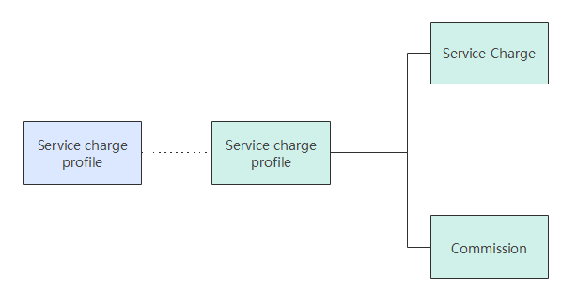

Service Charge and commissions can be applied to all Financial Services and some Non-Financial Services.

**Service charges:** Refer to the amount that an MFS provider receives for a transaction. This fee is charged to the user for a transaction. This fee is sent to Orange. A service charge is mandatory to be configured for each transaction.

**Commission:** Refer to the amount that an MFS provider (Orange), channel user, subscriber receives for a transaction.

### Subscription on the USSD interface by an agent

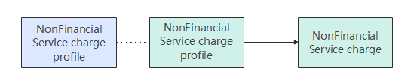

**Non-Financial Service Charge:** Refer to the service charge for a non-Financial transaction for a specific grade. This enables the operator to charge its Orange Money users for any non-financial transactions.

### Subscribers Self Subscription on the USSD

**Promotions:** Orange Money allows to apply a specified promotion service charge to a defined set of subscribers in a period time, and the subscribers will back to original service charge after promotion.

## How to work in the legacy system

### Subscription on the web interface by an agent

Orange Money allows to apply Service Charges and Commissions for different services in terms of Transaction Value or Percentage. Commissions and service charges are defined between 2 grades.

There is a feasibility to pay commission to one or more channel users in a single transaction. Example in Cashin transaction, the retailer and his wholesaler may receive some commission from MFS Provider.

Service Charge and Commissions can be configured in following ways:

* + - Flat fee
    - Flat fee depending upon transaction amount slabs
    - Percentage of the transaction amount
    - Percentage of the transaction amount in slabs
    - Flat fee + percentage of the transaction amount
    - Flat fee + percentage of the transaction amount in slabs
    - Support multiple versions of service charge profiles, for each version has mutual exclusive validity duration, and only one version will be valid at one time.

Defined in service charge profiles, service charge can be:

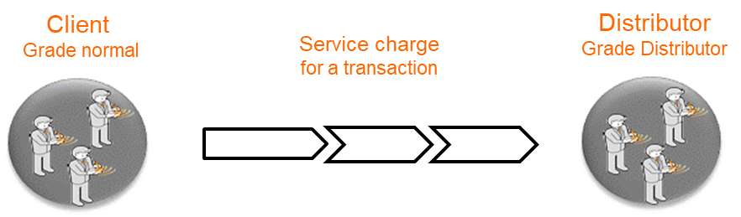

* + - Between whom: sender grade & receiver grade
    - Amount of the transaction: minimum & maximum & multiple of
    - Who pays: client, distributor (Channel user)
    - Who receives: Orange account
    - Configuration of service price: Minimum billed in % and / or fixed amount, Maximum billed in % and / or fixed amount, Define a % or fixed amount per slab

Defined in service charge profiles, service charge can be:

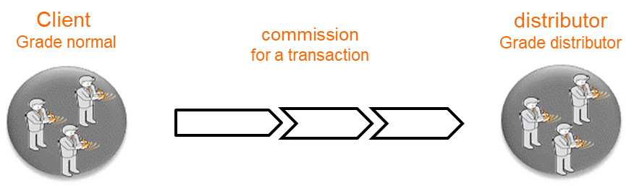

* + - Who pays: Orange account, subscriber, channel user
    - Who receives: client, distributor
    - Configuration of service price: Minimum payed in % and / or fixed ammount, Maximum payed in % and / or fixed ammount, Define a % or fixed amount per slab

### Subscription on the USSD interface by an agent

Orange Money allows to apply a Non-Financial service charge only for non-financial transaction for a specific grade. No transfer rules, authentication and Thresholds (TCP) will be applicable for Non-Financial transactions, it can be:

* + - Only with fixed amount charge
    - There is system preference to govern if creation of non-financial charge is mandatory or not

Note: There is no configuration of non-financial service charge in the legacy system, and it might be not necessary as well.

### Subscribers Self Subscription on the USSD

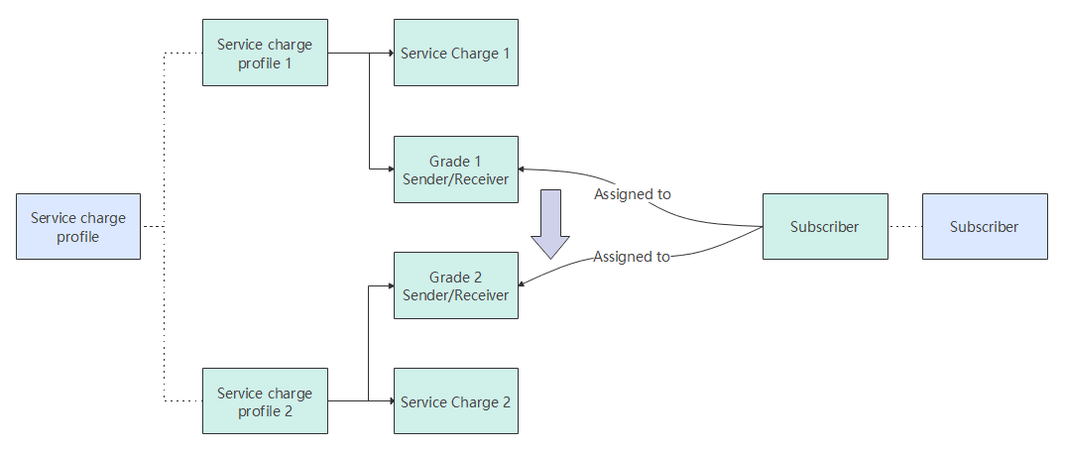

It can be configured as follows:

* Create a grade 2, service charge profile 2 for promotion
* Transfer the subscriber to the grade 2
* At end of the promotion Transfer the subscriber back to the grade 1

## How to work in the Mobile Money Core

### Subscription on the web interface by an agent

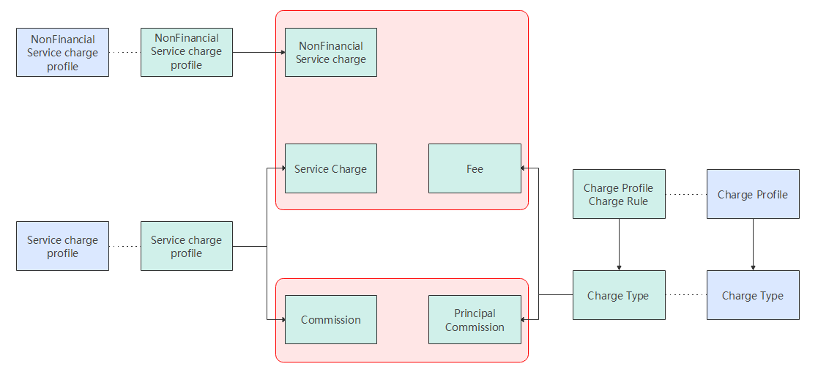

There are charges and commissions concept in the Mobile Money Core, but both the detailed meaning and working mechanism are different.

**Charge Type:** defines the service handling fee or commission payers or receivers involved in various transactions or actions, party of the charge profile from which the charging amount is obtained during charging, and statement details recorded in the accounts of the debit and credit parties during charging.

**Charge Profile:** defines the charge rate of a handling fee or commission in a transaction or service operation based on a charge type. Charge profile can be assigned to specified products and identities.

**Fee:** service handling fees paid to the SP by identities that use system services. The identities include the credit or debit party of a transaction and the initiator or receiver of an action. For this charge type, receivers are always the SP, and payers are configurable. It can replace Service charge and non-financial service charge concept.

**Principal Commission:** commissions obtained by agent organizations from the SP due to service provision to customers. For this charge type, payers are always the SP but receivers can be the credit or debit party of a transaction or the initiator or receiver of an action. It can replace commission concept.

Fee and Principal Commission can be configured in following ways that legacy system can support, but in different working mechanisms:

* Flat fee
* Flat fee depending upon transaction principal amount tiers
* Percentage of the transaction principal amount
* Percentage of the transaction principal amount in tiers
* Flat fee + percentage of the transaction principal amount
* Flat fee + percentage of the transaction principal amount in tiers
* Support multiple versions of charge profiles and charge types, for each version can have mutual exclusive validity duration, and only one version will be active at one time, but need manually change active version. To realize automatically change fee and commission based on validity duration, it can be configured on charge rules within charge profiles module.

In charge Type and Charge Profile, there are some parameters that not support as follows:

* + - Amount of the transaction: minimum & maximum & multiple of
    - Configuration of fee and commission: Minimum billed in fixed amount, Maximum billed in fixed amount

The Charge Type can also be configured as follows:

* Category: Extra fee, Liable Commission, Residual Commission
* Charge Mode: Increase and Decrease

The Charge profile can also be configured as follows:

* Charge rules to support dynamic pricing, for more details, please refer to dynamic pricing FRS document.

### Subscription on the USSD interface by an agent

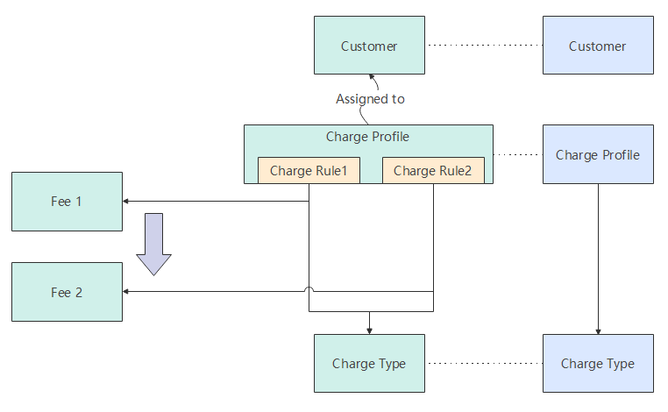

There is no grade concept in the Mobile Money Core, Charge Rule concept will be used to configure dynamic pricing, it can support multiple related charge conditions, only when charge condition is met, the charge is then calculated and considered during the optimal charge determination. Charge condition can support expression with transaction factors, identity information, etc.

To realize promotion, it can be configured as follows:

* Create a Charge Rule 2, Fee 2 for promotion
* Transfer the Charge Rule 1(Fee 1) to Charge Rule 2(the Fee 2) via condition expression
* At end of the promotion Transfer the Charge Rule 2(Fee 2) to Charge Rule 1(the Fee 1)

### Subscribers Self Subscription on the USSD

**Tax:** Tax authorities collect taxes on service handling fees or commissions generated during transactions in the Mobile Money Core. Both tax charge type and tax code are used to perform tax management.

**Tax Charge Type:** Specifies a taxing reference object, reason type for a taxed transaction, tax payer and receiver, and account statement information recorded by the system during taxing. The system supports the following taxing reference objects:

* **Primary transaction amount:** The primary transaction amount is used as a reference object to calculate taxes. It can replace tax collected on the amount of the transaction concept.
* **Charge amount:** The charge amount is used as a reference object to calculate taxes. It can replace tax collected on the service charge and commission.

**Tax Code:** Various types of taxes are defined as tax codes in the Mobile Money Core. A tax code defines a tax rate, taxing model, and tax charge type used for taxing. It can be configured as follows:

* Tax Model: Increase and Decrease
* Rate Type: Fixed and Percentage
* Rate Mode: Static pricing and dynamic pricing
* Rank Flag: No rank, Step, Tier

# Organization Registration

## Definition

In addition to individual customers, the mobile payment service ecosystem also involves some organizations, including agents helping SP provide customer service (such as customer registration, deposit, and withdrawal), merchants selling products, organizations receiving bill payment, and MNOs receiving airtime purchase.

Organizations participating in mobile payment must be registered within the Mobile Money Wallet to facilitate the management of organization information and behavior.

## Benefits

Benefits of this feature

| For... | Benefits |
| --- | --- |
| SP | SP can record information about various organizations participating in mobile payment service, facilitating the management of these organizations. In addition, SP can attract more organizations to participate in mobile payment, expanding the service scope of mobile payment, adding the customer value of mobile payment, and obtaining more profits. |
| Individual customers | Individual customers can use services provided by various organizations in the mobile payment ecosystem. |
| Organizations | Organizations can participate in the mobile payment ecosystem, provide services and share profits with SP, and improve the quality of their own services. |

## Description

The Mobile Money Wallet allows SP and organization operators to register an organization through channels such as the web, bulk, and API.

To register an organization, the operator needs to:

* Specify an organization short code or use an organization short code automatically generated by the system to uniquely identify the organization.
* Enter an organization name.
* Specify a parent organization if the organization is a child organization.
* Enter the organization KYC information, including the organization address, contact, bank account, and region. KYC fields that need to be recorded can be customized in different local markets.
* Assign products to the organization. The operator can set different extended attributes (for example, whether the Pay Bill organization supports C2O link, O2O link, and the validation rule of bill reference number) for different products.
* Specify the charge profiles (at the identity level or product level) of the organization's charge and commission pricing.
* Specify the limit rule profile of the transaction or operation of the organization and its account.
* Specify the revenue settlement profile of the organization and set related revenue settlement parameters.
* Specify an accounting model if the organization is a top-level organization.
* Specify a charge distribution model if the organization is an aggregated child organization.
* Specify exempted tax codes for the organization.

SP operators can create both top-level organizations and child organizations. Organization operators can create only child organizations of their own organizations.

## Requirements

Requirements on the System

This feature is a basic feature and does not involve interaction with external systems if organizations are registered on the web portal.

If organizations are registered through the API, a third-party system needs to be provided to invoke the generic API of the Mobile Money Wallet using the SOAP (over HTTPS) protocol.

Requirements on the Network

When organizations are required to be registered through the API, the SOAP (over HTTPS) API must be exposed to third-party systems.

## Impact on the System

None

## Application Limitations

None

## Feature Interactions

Feature Dependencies

This feature depends on the Organization KYC Management, Organization Product Management, Charging Management, Limit, and Organization Revenue Settlement features. Based on these features, the corresponding organization information needs to be entered during organization registration.

Mutually Exclusive Features

None

## Technical Description

### Architecture

None

### Business Process

Figure 1-1 shows the process of registering an organization on the portal.

Process of registering an organization on the portal

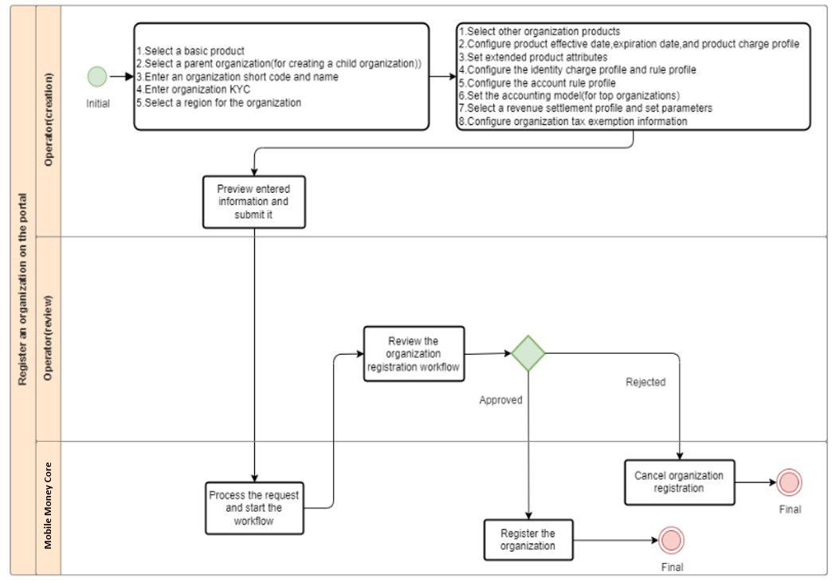

Whether organization registration needs an approval process depends on the workflow configuration. (Typically, approval process is required.) If organization registration does not need an approval process, the system directly registers an organization after an organization registration request is submitted.

The process of registering an organization through the API complies with the common business process of the generic API. For registering an organization through the API, whether an approval process is required depends on the workflow configuration. If yes, the request needs to be approved on the portal.

The process of registering organizations in bulk is the same as that of other bulk tasks. An operator can upload a bulk file on the portal to create a bulk task of registering organizations in bulk. During bulk organization registration, a single organization does not need an approval process. Whether organization registration needs an approval process depends on the workflow configuration. (Typically, approval process is required.)

### User Experience

After being registered in the Mobile Money Core, an organization can use services provided by the Mobile Money Core or provide agent services for a service provider (SP).

###### Prerequisites

The role of the Organization has been created.



The role of the SP operator who logs in to the Portal must be controlled by the role of the organization to be created.

###### Procedure

1. Choose **Identity** > **Organization** > **Create** > **Top Organization**. (Figure 2-2).

Organization creation process.

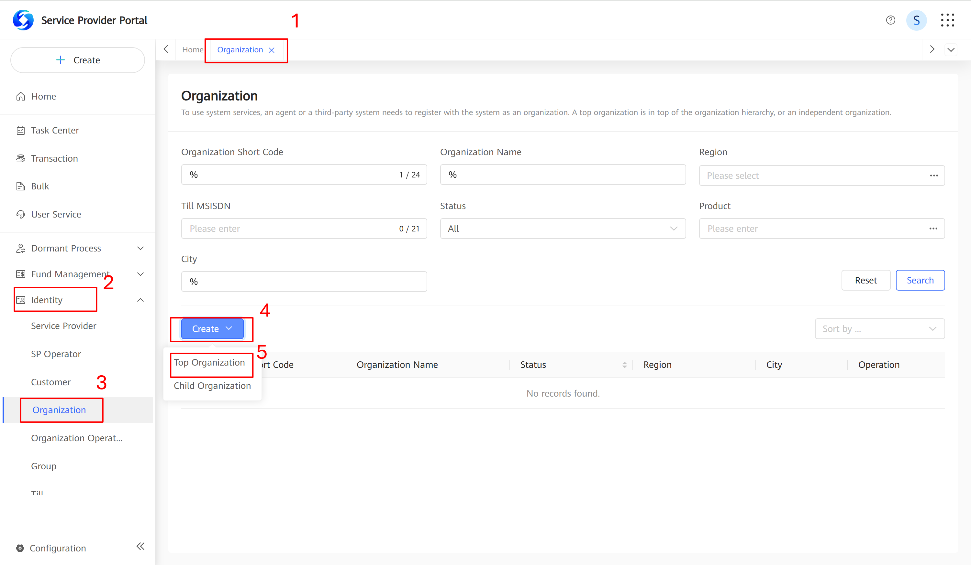

1. Configure identity information on the **Organization Info** tab page.
   1. In the **Basic Product** area, click **Add**, select roles for the organization, and click **Confirm**.

Organization Information integration.

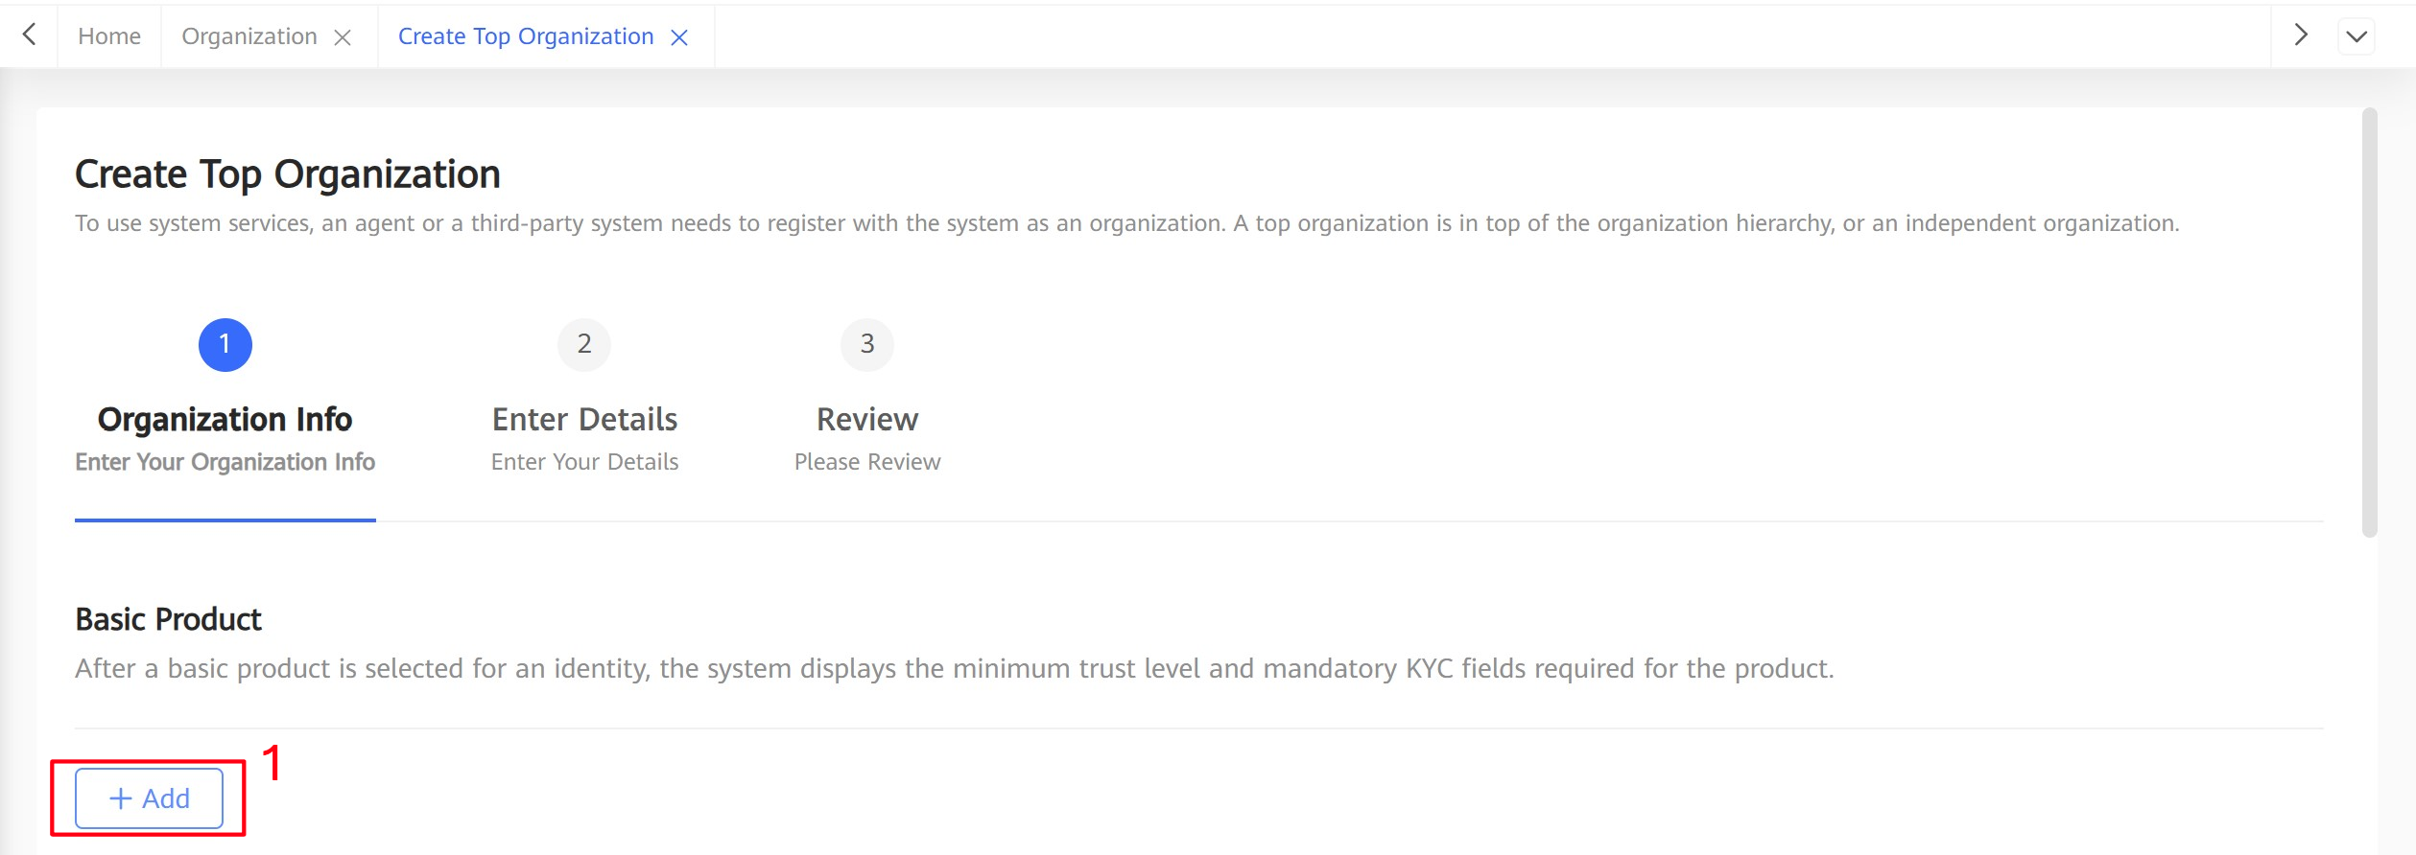

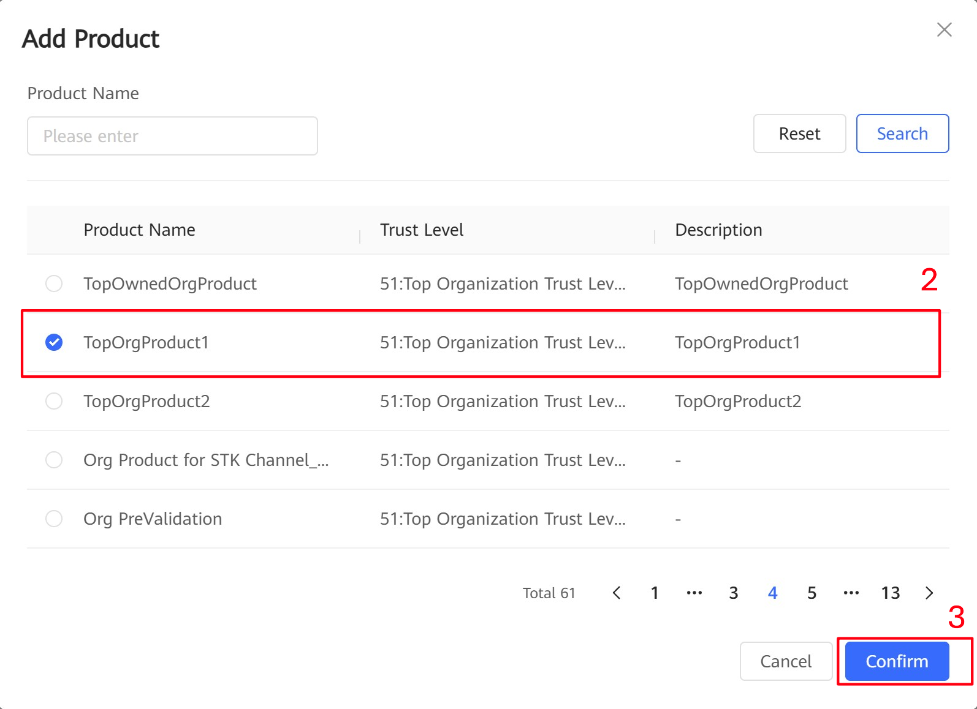

After you select roles, the system automatically displays and selects the list of products associated with the roles.

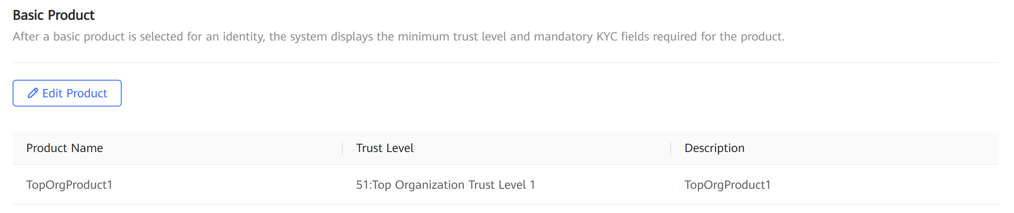

**Effective Date** and **Expiry Date** can be modified for all products.

You can click **Edit Product** to reselect a value.

* 1. In the **Identity Info** area, enter **Short Code** and **Organization Name**.

**Short Code**: organization short code, which consists of eight digits.

**Organization Name:** The specified name of an Organization.

Organization Short code and name.

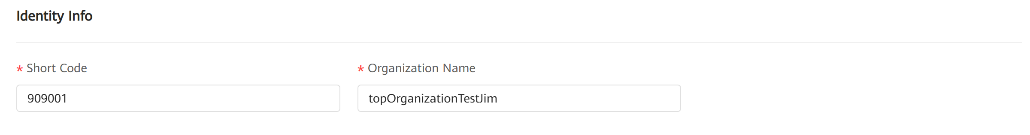

* 1. In the **KYC Info** area, set the KYC information for the organization.
  2. Click **Next**.

Top Organization KYC info Management.

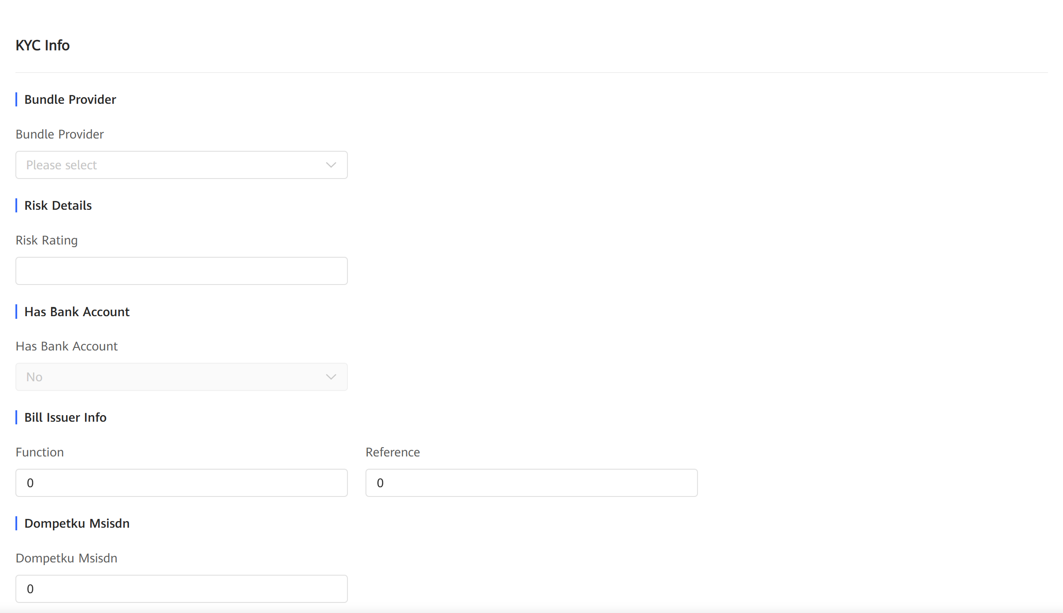

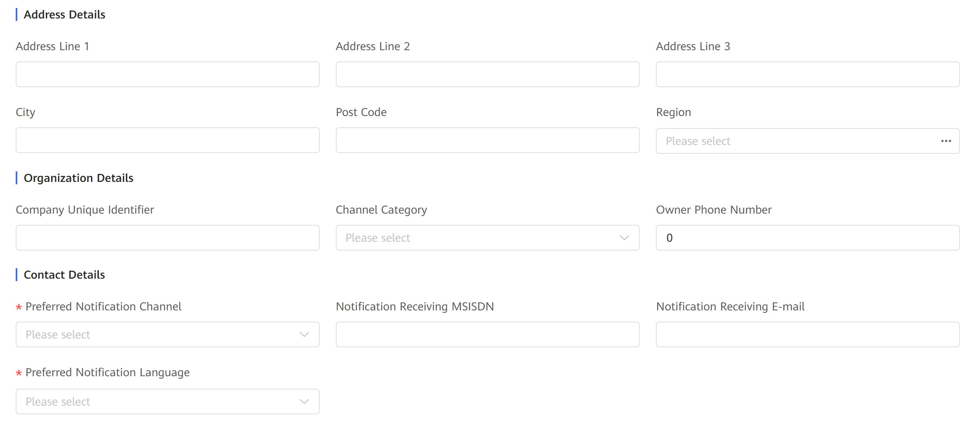

KYC Info and description.

|  |  |  |  |
| --- | --- | --- | --- |
| **Parameter** | | | **Description** |
| **Bundle Provider** | | | Indicates whether the organization provides a set of services grouped into one package called bundle.  Select from the drop-down list box (**yes** or **no**). |
| **Risk Details | Risk Rating** | | | Indicates the rating of a risk.  An integer with a maximum of 9 digits. |
| **Has Bank Account** | | | Indicates whether an identity has a bank account. This parameter cannot be edited. |
| **Bill Issuer Info** | **Function** | | Indicates theFunctions of the bill issuer.  A string with maximum of 512 characters. |
| **Reference** | | Indicates the Reference information of the bill issuer.  A string with maximum of 512 characters. |
| **Dompetku Msisdn** | | | Indicates MSISDN of an organization that is involving a third-party Dompetku transaction. |
| **Address Details**  A string with a maximum of 255 characters, not containing any special characters except underscores (_), dots (.), and hyphens (-). | | **Address Line 1** | Indicates the first preferred address line of the organization. |
| **Address Line 2** | Indicates the second preferred address line of the organization.  Indicates the third preferred address line of the organization. |
| **Address Line 3** |
| **City** | | | Indicates the home city or hometown of the organization.  A string with a maximum of 255 characters, not containing any special characters except underscores (_), dots (.), and hyphens (-). |
| **Post Code** | | | Indicates the post code of an address.  A string with a maximum of 512 characters. |
| **Area** | | | Indicates the operation region of the organization. |
| **Company Unique Identifier** | | | Indicates the unique identifier of a company.  A string with a maximum of 512 characters. |
| **Channel Category** | | | Channel classification when an organization acts as a company. |
| **Owner phone Number** | | | Phone number of the owner of the organization.  A string with a maximum of 512 characters. |
| **Preferred Notification Channel** | | | Indicates the preferred notification channel. |
| **Notification Receiving MSISDN** | | | Indicates the MSISDN for receiving notifications.  A numeral string which length can be configured in a system parameter. |
| **Notification Receiving E-mail** | | | Indicates the email address for receiving notifications.  A string with a maximum of 512 characters. |
| **Preferred Notification Language** | | | Indicates an identity's preferential language in notifications. |

Organization ID KYC Details.

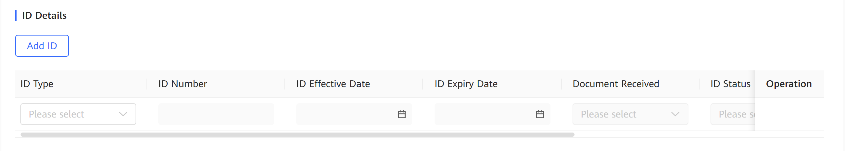

ID Details Description.

|  |  |
| --- | --- |
| **Parameter** | **Description** |
| ID Type | Indicates an ID type. |
| ID Number | Indicates an ID number.  A string with a maximum of 16 characters. |
| ID Effective Date | Indicates the effective date of an ID. |
| ID Expiry Date | Indicates the expiration date of an ID. |
| Document Received | Indicates whether an original ID or ID copy is documented. |
| ID Status | ID document status. |
| Issued By | Issuer of an identity's ID document.  A string with a maximum of 512 characters. |
| ID Location | External file location for the ID document.  A string with a maximum of 512 characters. |

Organization Certificate KYC Details.

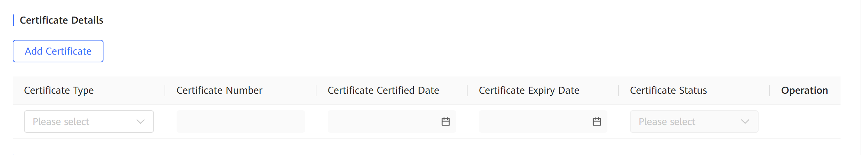

Certificate Details Description.

|  |  |
| --- | --- |
| **Parameter** | **Description** |
| Certificate Type | Indicates a certificate type. |
| Certificate Number | Indicates a certificate number.  A string with a maximum of 16 characters. |
| Certificate Certified Date | Indicates the certified date of a certificate. |
| Certificate Expiry Date | Indicates the expiration date of a certificate. |
| Certificate Status | Indicates the status of a certificate. |

Top Organization Contact KYC Details.

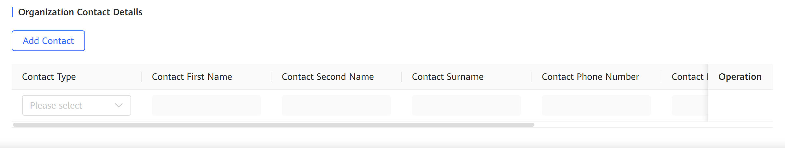

Contact KYC Details Description.

|  |  |
| --- | --- |
| **Parameter** | **Description** |
| Contact Type | Indicates a contact type. |
| Contact First Name | Indicates the first name of a contact.  A string with a maximum of 64 characters, not containing any special characters except underscores (_), dots (.), and hyphens (-). |
| Contact Second Name | Indicates the second name of a contact.  A string with a maximum of 64 characters, not containing any special characters except underscores (_), dots (.), and hyphens (-). |
| Contact Surname | Indicates the last name of a contact.  A string with a maximum of 64 characters, not containing any special characters except underscores (_), dots (.), and hyphens (-). |
| Contact Phone Number | Indicates the phone number of a contact.  A string of 10 to 20 characters. |
| Contact Birthday | Indicates the birthday of a contact person. |
| Contact ID Type | Indicates the ID type of a contact. |
| Contact ID Number | Indicates the ID number of a contact.  A string of 4 to 16 characters. |
| Contact Email | Indicates the email address of a contact.  A string with a maximum of 512 characters. |

1. Configure details on the **Enter Details** tab page.
   1. In the **Trust Level and Segment** area, view the matched **Trust Level** and **Segment**.

**Trust Level** and **Segment** area the highest trust level and all segments that can be matched based on organization KYC information and cannot be modified. The trust level and segment of an organization determine the products, charge profiles, and rule profiles that can be used by the organization.

Trust Level and Segment Info.

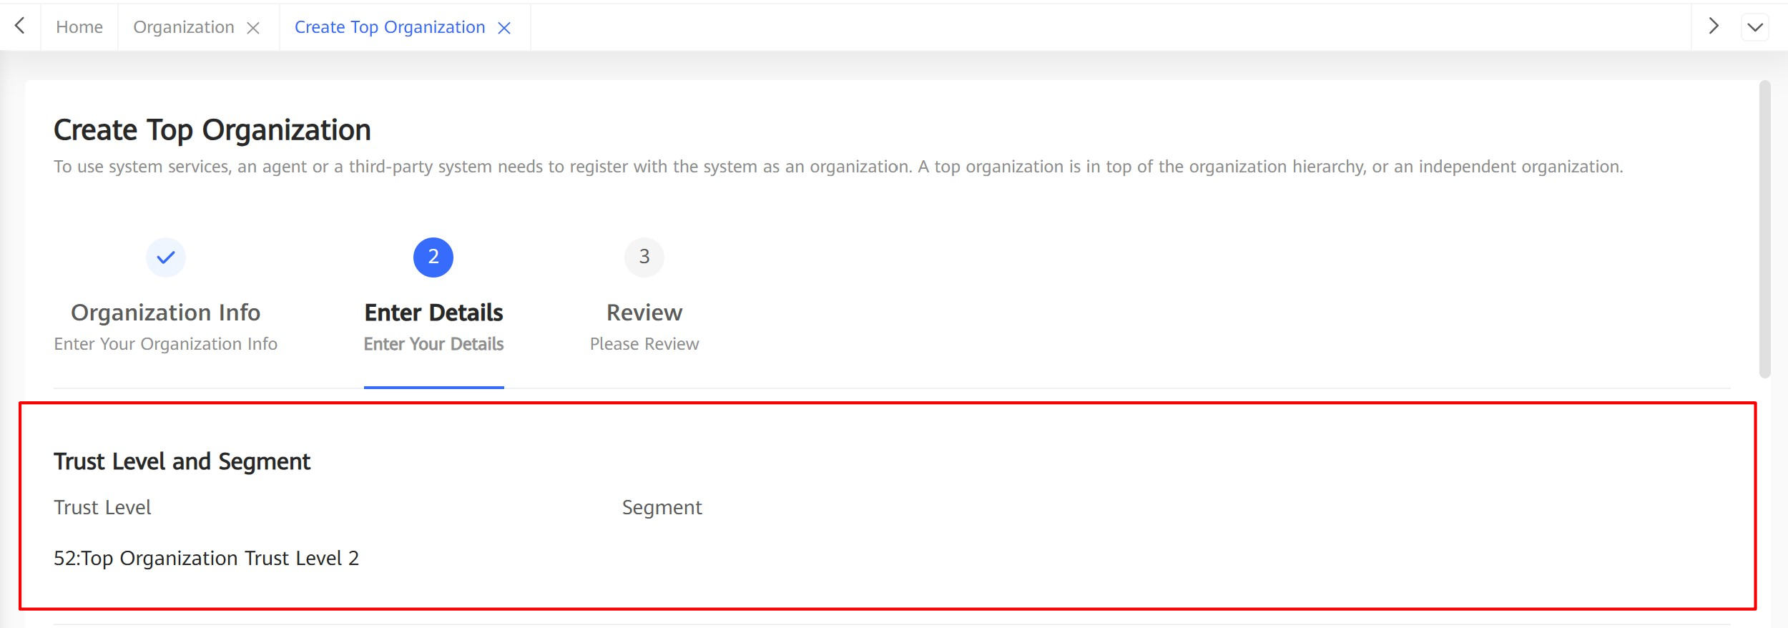

* 1. In the **Product** area click **Add Product**, select optional products for the organization, and click **Confirm**.

**Effective Date**, **Expiration Date**, and **Charge Profile** can be modified for all products.

Adding optional product profile.

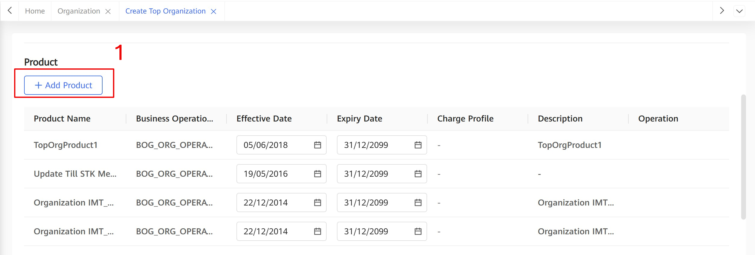

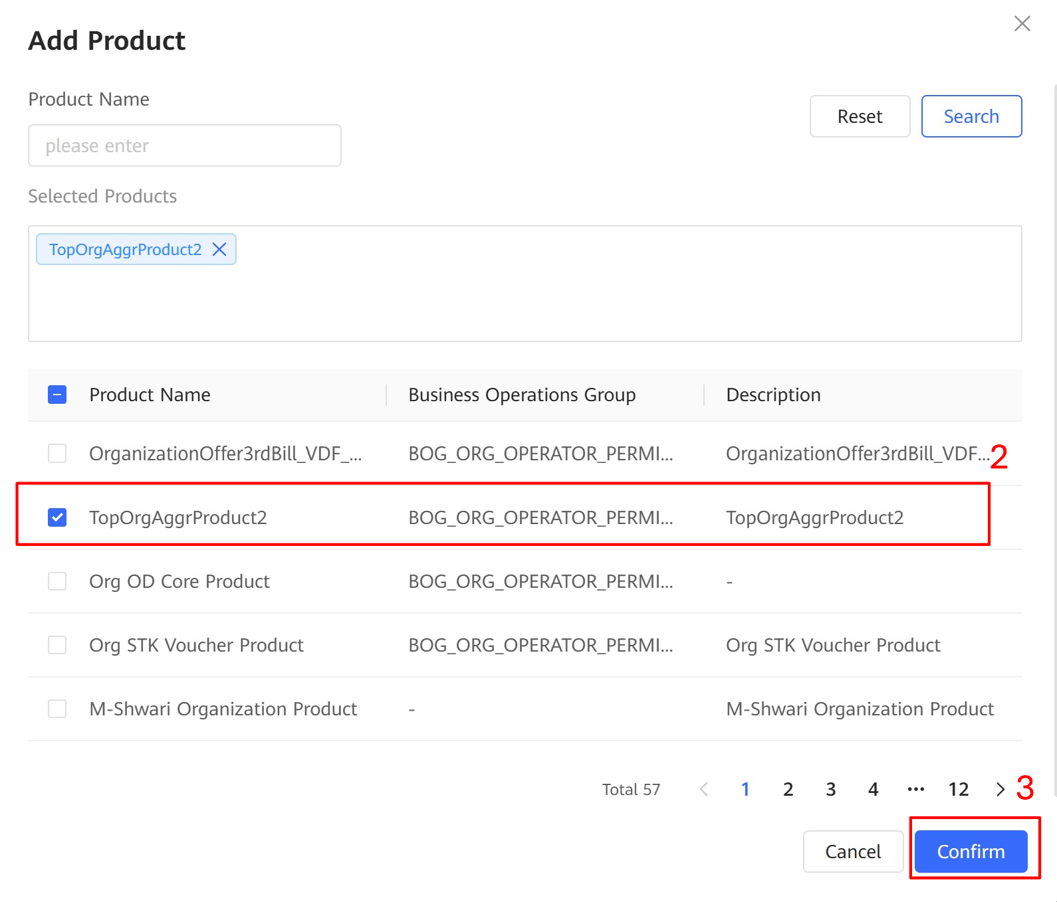

* 1. In the **Profile** area, set **Charge Profile** and **Rule Profile** from the dropdown list. You have also the option to use the default profiles for **Charge** and **Rule profile**.

Setting charge profile and rule profile.

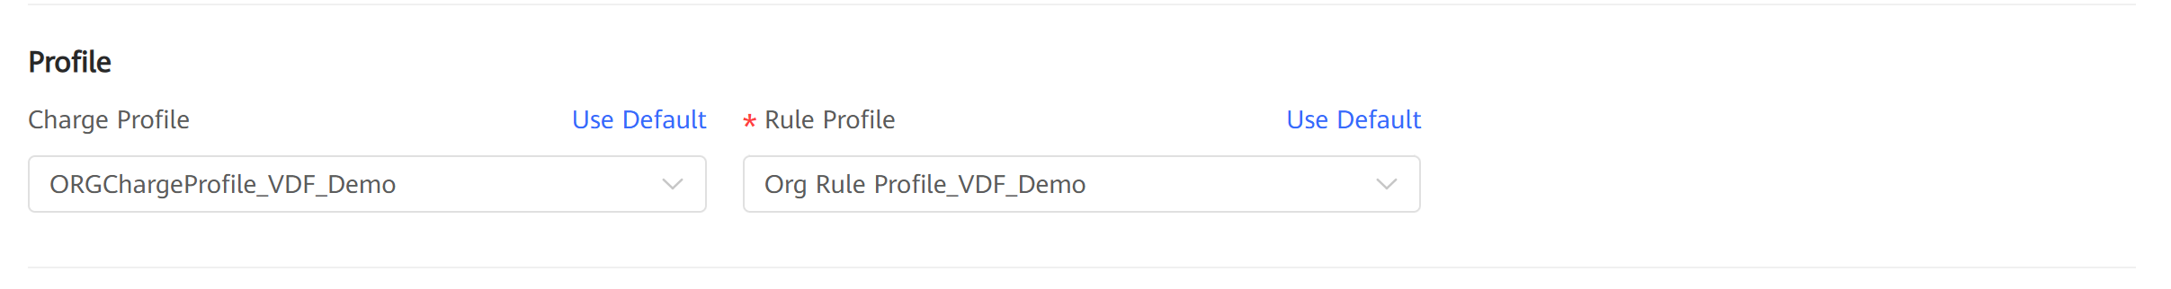

* 1. In the **Account** area, Configure **Rule Profile** information for each account.

Account profile information.

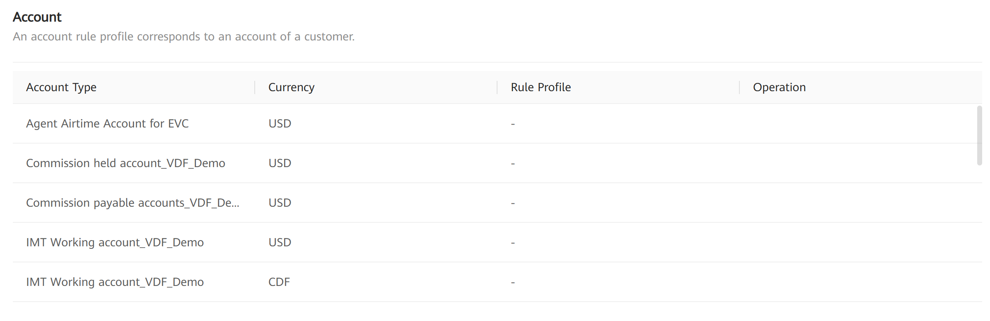

* 1. In the **Shared Model** area, configure the sub-organization of the top organization to the shared account level in franchised store mode and direct store mode.

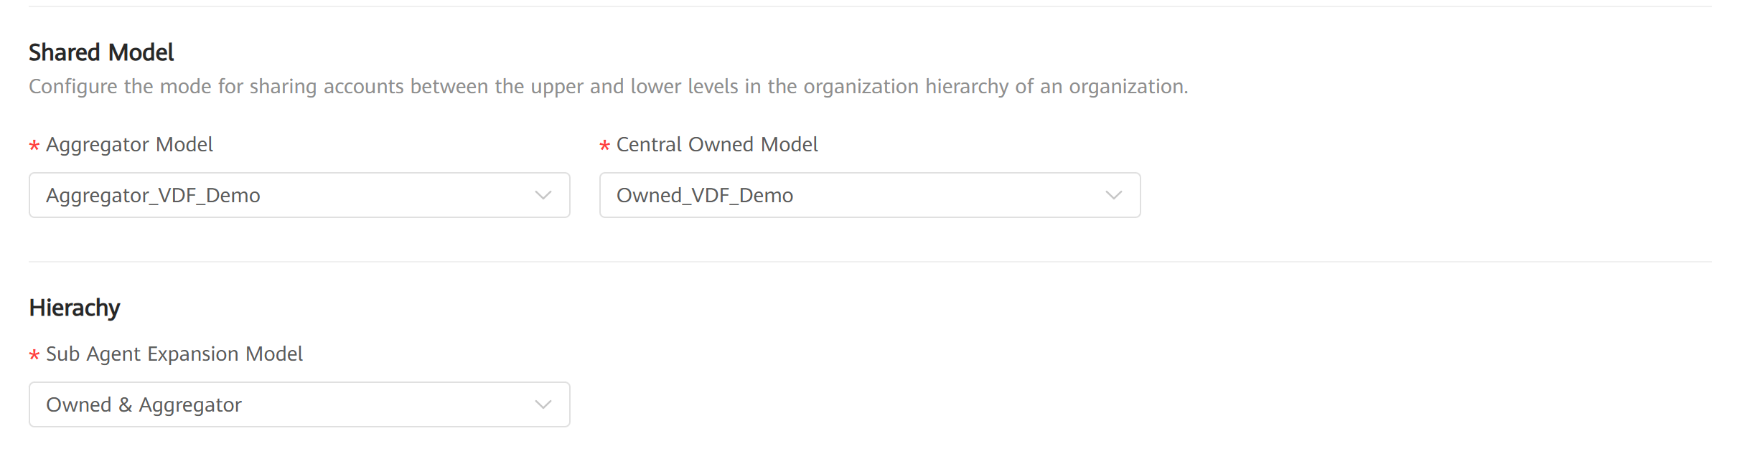

* + - **Aggregator Model**: the level of the shared account in the franchise mode.
    - **Central Owned Model**: the level of the shared account in the direct store mode.

**Organization hierarchy**: The level of a top-level organization is 1, the level of a sub-organization of a top-level organization is 2, the level of a sub-organization of a top-level organization is 3, and so on.

The levels of the Funds Sharing Model account are described as follows:

* + - When Funds Sharing Model is set to 0, organizations at all levels have their own accounts.
    - When Funds Sharing Model is set to 1, only the account types of top-level organizations can be shared.
    - When Funds Sharing Model is set to 2, it indicates that level-2 and higher organizations have their own independent accounts, and level-3 and lower-level organizations share the accounts of level-2 organizations (the organizations must be directly related). The rest may be deduced by analogy.
  1. In the **Hierarchy** area, configure organization type that can be created by a sub-organization of a top organization.

**Sub Agent Expansion Model**:

* + - NoneHierarchy: No child organization exists.
    - Can Make Aggregator: The sub-organization is of the franchise store type, and the sub-organization of the sub-organization can only be of the franchise store type.
    - Can Make Owned: The sub-organization is of the direct store type, and the sub-organization of the sub-organization can only be of the direct store type.
    - Can Make AllType: A child organization can be a direct store (owned) or franchised store (aggregator). There is no restriction on the type of the child organization.
  1. In the **Bill Reference Number Validation** area, configure the bill reference number validation rule for the organization as shown in the Figure 2-12.

Bill Reference Number Validation.

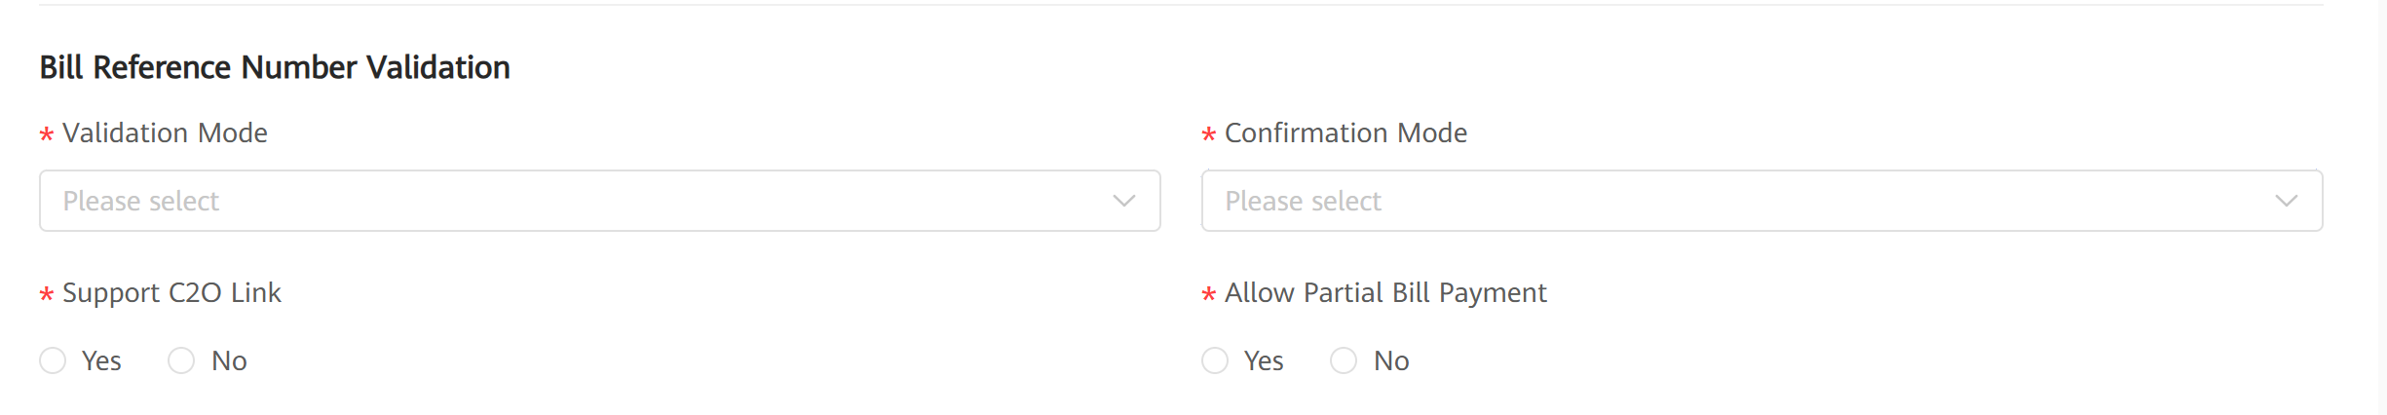

Bill Reference Number Validation

|  |  |
| --- | --- |
| **Parameter** | **Description** |
| Validation Mode | Validation mode. The options are as follows:   * + - **External Validation** : After a Pay Bill transaction is triggered, the Mobile Money Core sends a message to the third-party system. The third-party system performs verification and returns the verification result to the Mobile Money Core.     - **Internal Validation** : After a Pay Bill transaction is triggered, the Mobile Money Core will perform verification and return the result. No need for a third-party confirmation.     - **Internal and External** : The value will be validated against the configured regular expression. The regular expression can allow null value input. In the validation request sent to bill organization, the bill reference number field will be supplied only when it is already input for the pay bill transaction.     - **No validation** : After a Pay Bill transaction is triggered, no validation is required. |
| Regular Expression | Internal validation rule expression with standard regular expression. i.e. [a,z][A,Z]{1,9} |
| Validation Notification Text | Content of the notification found when the verification fails. |
| Confirmation Mode | indicates whether to send a notification to the third-party system after an order is completed. Values: **External Confirmation, No Confirmation** |
| Support C2O link | indicates whether the filter supports C2O links, C2O link refers a link between a customer and an organization in the pay bill service |
| Allow Partial Bill Payment | Indicates whether to support partial bill payment. The partial bill payment function applies to scenarios where the payment amount is less than the bill amount. |

* 1. In the **Commission Settlement Configuration** area, configure commission settlement.

Select a configured commission settlement template from the **Commission Settlement Configuration Template** drop-down list, as shown in Figure 2-13.

Selecting a commission template



* + - Click View Detail to view template details.
    - Click Edit Template to customize a commission settlement template. The modified template can be used only by the current organization.
  1. In the **Revenue Settlement Configuration** area, configure revenue settlement.

To facilitate the SP's net revenue settlement and net liability settlement, the Mobile Money Core system provides the revenue settlement service for the SP.

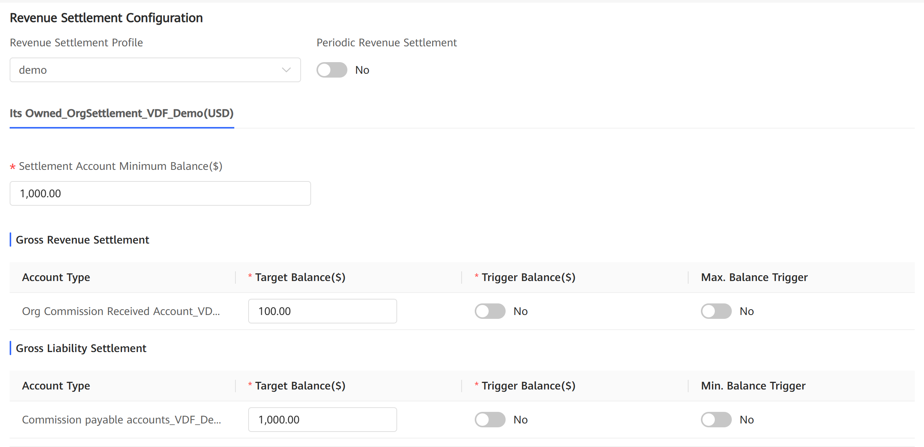

* 1. Click **Next**.

1. Confirm the organization information on the **Review** tab page.

Review Tab to review all configuration set for the Top Organization created.

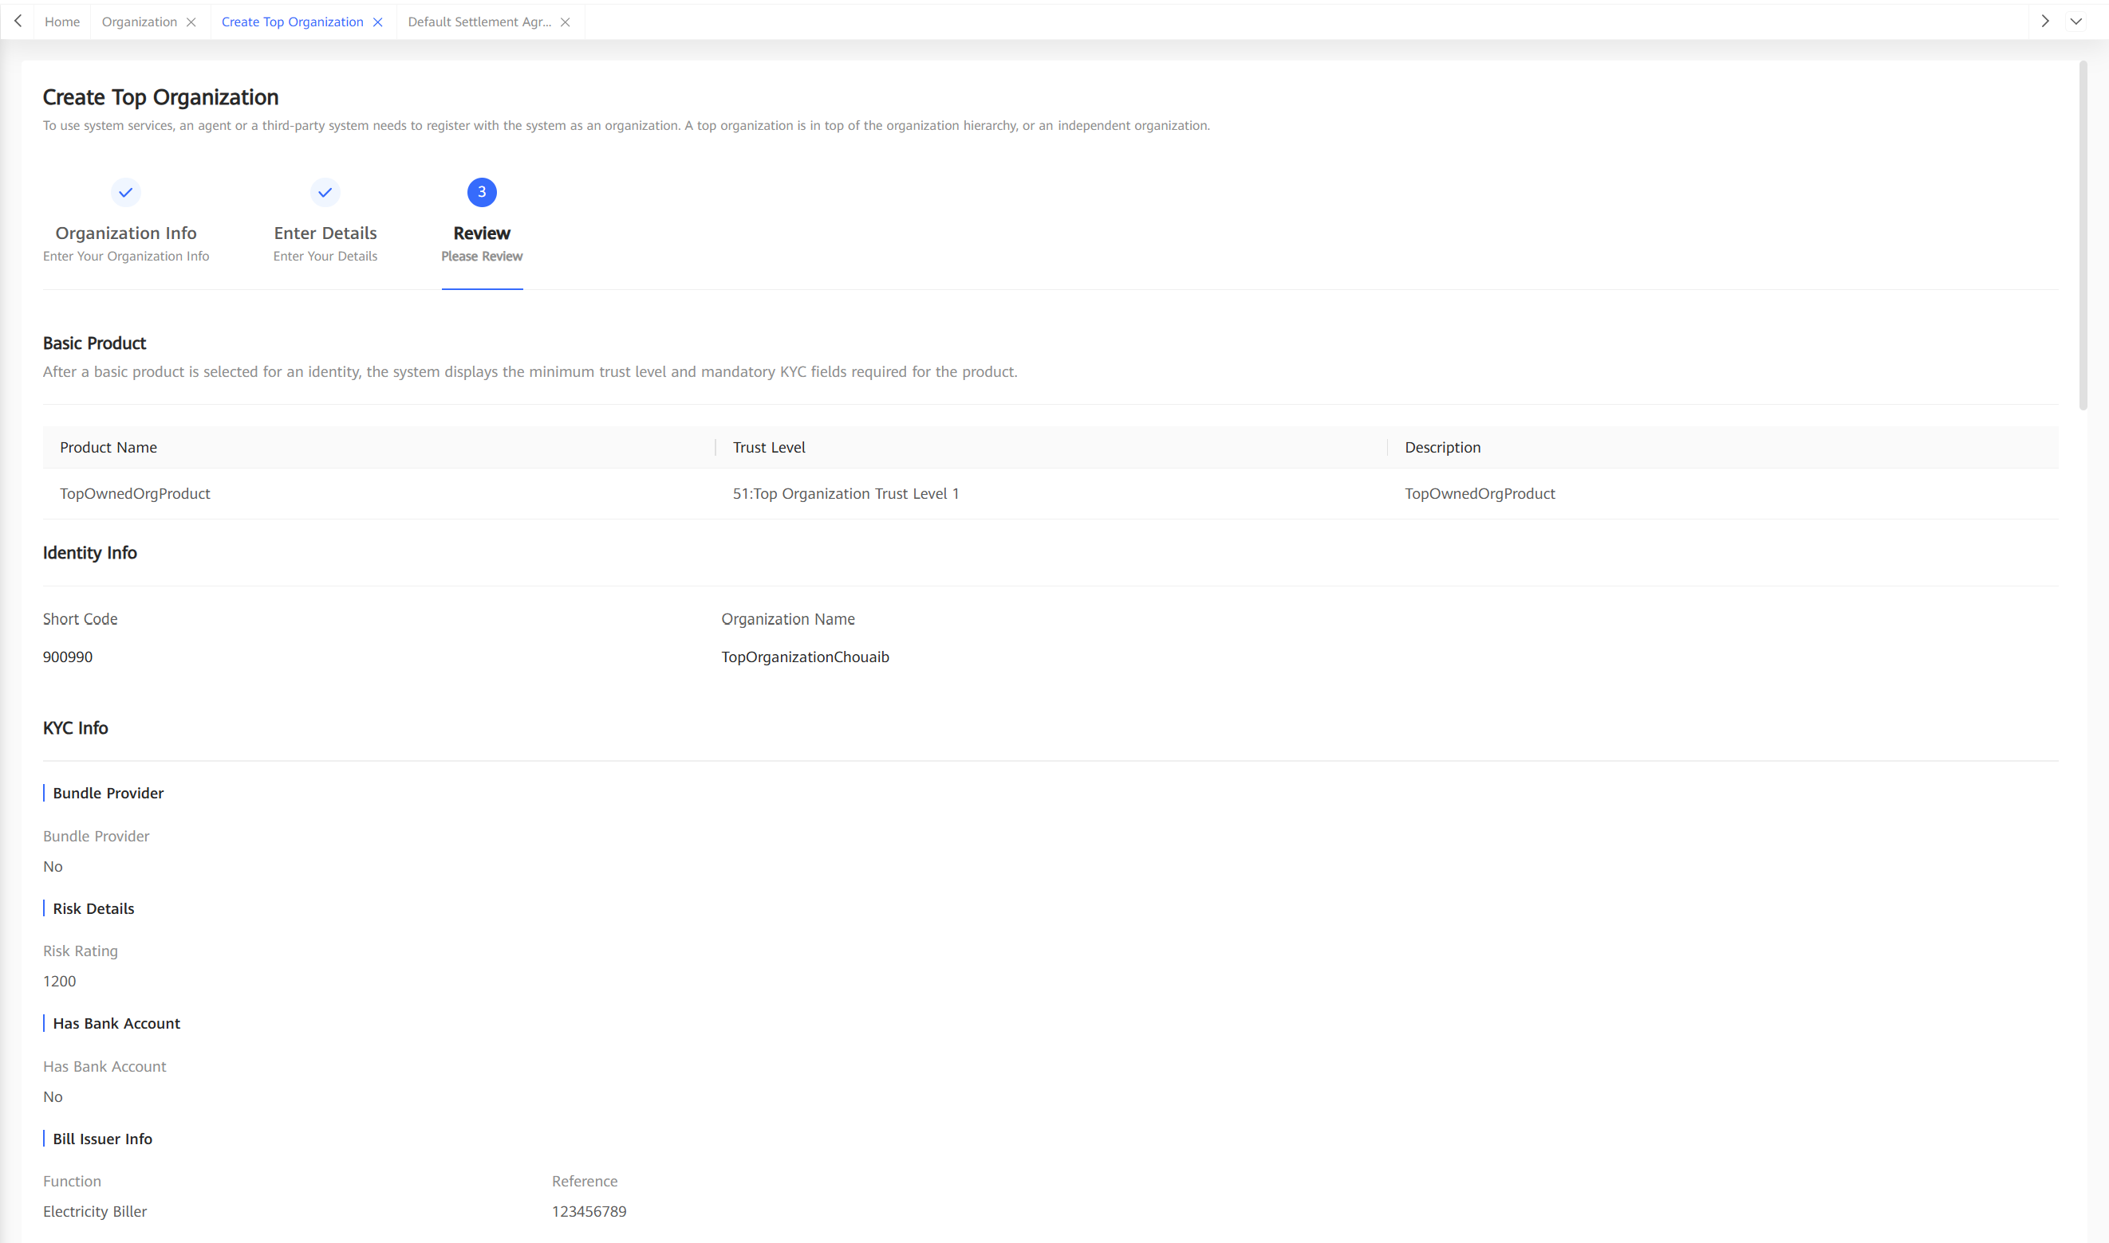

* 1. Check all information configured in 2 and 3.
  2. Click **Submit**.

After submitting a request to create an organization:

* + - If manual approval is required, the organization is in **New** state. After the organization is approved, the organization status changes from **New** to **Active**.
    - If manual approval is not required, the organization is in the **Active** state.

After related information is configured, the system displays the configured information. The operator can confirm the information and submit a request to register the organization.

After receiving a registration request, the system creates a workflow and determines whether the request needs an approval process based on the workflow configuration. User experience of the approval process is the same as that of other workflows.

User experience of registering an organization through the API is determined by the external system. The system determines whether the request needs to be approved based on the workflow configuration. If yes, the request needs to be approved on the portal and user experience is the same as that of registering an organization on the portal.

User experience of registering organizations in bulk is the same as that of other bulk tasks.

### Configuration Points

Permission

The role of operator needs an execution permission named **Create Top Organization** or **Create Child Organization** to create organization.

## Specifications

Technical Specifications

Table 1-2 describes organization information and service rules involved in organization registration.

Organization information and service rules involved in organization registration

| Organization Information | Service Rule |
| --- | --- |
| Organization short code | The organization short code is mandatory. The organization short code must be unique among organizations not in **Closed** state in the system. |
| Organization name | The organization name is mandatory. |
| Parent organization short code | The parent organization short code is mandatory for registering a child organization. When a child organization is registered, the parent organization must be in **Active** state. |
| KYC | Some function-related KYC fields are preset in the system. Operators can use or not use these KYC fields based on function requirements of the local market. The local market can also define some KYC fields based on their service requirements.  When configuring KYC fields required for an organization, an operator can specify whether the KYC fields are mandatory or optional.  When an organization is created, the system determines the organization's trust level based on whether the KYC fields of the organization are set and determines the organization's segment based on some KYC fields.  For details, see the Organization KYC Management feature.  In addition to mandatory KYC fields defined in KYC configuration, after a basic product is selected when an organization is to be created on the web portal, the system also determine some more mandatory KYC fields based on the product definition. For details, see the Organization Product Assignment feature. |
| Trust level | Multiple organization trust levels and KYC fields required for each trust level can be defined in the system.  When an organization is registered, the system automatically determines the trust level of the organization based on whether the KYC fields are set. The highest trust level is selected when multiple trust levels are met.  For details, see the Organization KYC Management feature. |
| Segment | The system defines segments corresponding to the value ranges of different KYC fields (**Segment Type**).  When an organization is registered, the system automatically matches segments based on whether the KYC fields are set.  For details, see the Organization KYC Management feature. |
| Product | One or more products need to be assigned to an organization when the organization is created.  The applicable product range of different trust levels can be defined in the system. When an organization is registered, products assigned to the organization must be in the product range corresponding to the trust level of the organization.  The system can define default products for each segment. When an organization is registered, the system automatically assigns the default products corresponding to the segment to the organization. When multiple segments exist, default products corresponding to the segments are all assigned to the organization.  Products assigned to an organization must comply with the hierarchy type restrictions. For details, see the hierarchy type description.  When products are assigned to an organization, the operator can specify the effective and expiration dates for the products.  For details, see the Organization Product Assignment feature. |
| Hierarchy type | Applicable hierarchy types are defined for products. The hierarchy types are as follows:   * Aggregator * Centrally Owned * Non-Hierarchy   All three hierarchy types of products can be assigned to top-level organizations.  Non-hierarchy products can always be assigned to child organizations. However, centrally owned products and aggregator products cannot be both assigned to one child organization. A centrally owned or aggregator product can be assigned to a child organization only when the parent organization of the child organization is assigned with the same hierarchy type of product.  A child organization cannot have only non-hierarchy products.  Based on product assignment, organization hierarchy types are as follows:   * Aggregator: Have aggregator products only. * Centrally Owned: Have centrally owned products only. * Mixed: Have both aggregator products and centrally owned products. This type is applicable only to top-level organizations. * Non-Hierarchy: Have only non-hierarchy products. This type is applicable only to top-level organizations. |
| Extended product attributes | Some extended attributes can be defined for a product, for example, whether the Pay Bill organization supports C2O link, O2O link, and the validation rule of the bill reference number.  When a product is assigned to an organization during organization registration, related extended attributes must be set based on the product definition.  For details, see the Organization Product Assignment feature. |
| Product charge profile | When an organization is registered, a product charge profile can be configured for each product assigned to the organization. The product charge profile is optional. If the product charge profile is not configured, the organization charge profile is used for charge rating.  Applicable charge profiles and default charge profiles for organization products at different trust levels can be defined in the system.  Default charge profiles of segments for organization products at different trust levels and the priority of segment types can be configured in the system.  If an organization is assigned with multiple segments of different segment types, the system determines the default charge profile of a product based on segment type priorities. If the default charge profile is not configured for a segment, the system uses the default charge profile corresponding to the product trust level.  When the charge profile is manually selected for a product, the selected charge profile must be one of the applicable charge profiles corresponding to the trust level.  For details, see the Organization Product Assignment and Charging Management features. |
| Organization charge profile | When an organization is registered, an organization charge profile can be configured for the organization. The organization charge profile is optional. If the organization charge profile is not configured, the global system default charge profile is used for charge rating.  Applicable charge profiles and default charge profiles for organizations at different trust levels can be configured in the system.  Default charge profiles of segments for organizations at different trust levels and the priority of segments can be configured in the system.  If an organization is assigned with multiple segments of different segment types, the system determines the default charge profile based on segment type priorities. If the default charge profile is not configured for a segment, the system uses the default charge profile corresponding to the trust level.  When the charge profile is manually selected for a product, the selected charge profile must be one of the applicable charge profiles corresponding to the trust level.  For details, see the Charging Management feature. |
| Organization rule profile | When an organization is registered, an organization rule profile must be configured for the organization.  An operator can define applicable rule profiles and default rule profiles for organizations at different trust levels.  An operator can also define default rule profiles of segments for organizations at different trust levels and define the segment type sequence.  If an organization is assigned with multiple segments of different segment types, the system determines the default rule profile based on segment type priorities. If the default rule profile is not configured for a segment, the system uses the default rule profile corresponding to the trust level.  When the rule profile is manually selected for a product, the selected rule profile must be one of the applicable rule profiles corresponding to the trust level.  For details, see the Limit Configuration feature. |
| Account rule profile | When an organization is registered, the system can generate an account list of the organization based on the definition of products assigned to the organization. An account rule profile can be configured for each account. If the attribute of an account type specifies that an account rule profile is required, the account rule profile must be configured.  Applicable rule profiles and default rule profiles for organization accounts at different trust levels can be configured in the system.  Default rule profiles of segments for organization accounts at different trust levels and the priority of segments can be configured in the system.  If an organization is assigned with multiple segments of different segment types, the system determines the default rule profile of an account based on segment type priorities. If the default rule profile is not configured for a segment, the system uses the default rule profile corresponding to the trust level.  When the rule profile is manually selected for an account, the selected rule profile must be one of the applicable rule profiles corresponding to the trust level.  For details, see the Limit Configuration feature. |
| Accounting model | The accounting model that needs to be configured for a top-level organization is determined based on the hierarchy type.   * If the top-level organization is an aggregator organization, the aggregator accounting model needs to be configured. * If the top-level organization is a centrally owned organization, the centrally owned accounting model needs to be configured. * If the top-level organization is a mixed organization, both the aggregator accounting model and centrally owned accounting model need to be configured. * If the top-level organization is a non-hierarchy organization, the accounting model does not need to be configured.   For details, see the Account Management feature. |
| Charge distribution model | The system determines whether the charge distribution model needs to be configured for a child organization based on the hierarchy type.  The charge distribution model must be configured when the hierarchy type is **Aggregator** and does not need to be configured when the hierarchy type is **Centrally Owned**.  For details, see the Charging feature. |
| Revenue settlement | When an organization is registered, an operator can specify whether the organization supports organization revenue settlement.  If the organization revenue settlement is supported, the operator needs to configure a settlement profile, specify whether the settlement needs to be periodically executed, and set the settlement period. In addition, the operator also needs to set the target balance and trigger balance of accounts related to the settlement.  For details, see the Organization Revenue Settlement feature. |
| Tax exemption | When an organization is registered, an operator can specify whether the organization is exempted from taxes and what the exempted tax codes are.  For details, see the Tax feature. |

Standards Compliance

None

## Enhancements

None

## Reference

None

# Organization Life Cycle Management

## Definition

Organizations are identities that participate in services of the System (Mobile Money Wallet). During service operation of the System, organization life cycles need to be managed, including updating the organization identity status.

For example, when an organization acts suspiciously, the system needs to suspend or freeze the organization. When an organization is dismissed or deregistered from the System, the organization must be closed in the System.

## Benefits

Benefits of this feature

| For... | Benefits |
| --- | --- |
| SP | The SP can manage organization status based on the service requirements during the operation of the System.  When risks are detected for organizations, the SP can suspend or freeze the organizations to avoid risks, improve service quality, and reduce loss. After the risks are eliminated, SP can resume or unfreeze the organizations.  When an organization is dismissed or deregistered from the System, SP can close the organization in the System. |
| Individual customers | N/A |
| Organizations | Organizations can apply to SP or their parent organizations for changing their status based on the service requirements.  When organizations are close or to avoid risks, organizations can apply for suspension or freezing. After the organizations open again or the risks are eliminated, the organizations can apply for resumption or unfreezing.  When being dismissed or deregistered from the System, organizations can apply for closing.  Parent organizations can manage status of their child organizations based on the service requirements.  When risks are detected for child organizations, parent organizations can suspend or freeze the child organizations to avoid risks, improve service quality, and reduce loss. After the risks are eliminated, parent organizations can resume or unfreeze the child organizations.  When child organizations are dismissed or deregistered from the System, parent organizations can close the child organizations in the System. |

## Description

The System allows SP and organization operators to manage the status of an organization through channels such as the web, bulk, and API.

SP operators can manage status of all top-level organizations and child organizations in the system. Organization operators can manage only status of child organizations of their own organizations.

## Requirements

Requirements on the System

This feature is a basic feature and does not involve interaction with external systems if organization status is managed on the web portal.

If organization status is managed through the API, a third-party system needs to be provided to invoke the generic API of the System using the SOAP (over HTTPS) protocol.

Requirements on the Network

When organization status can be managed through the API, the SOAP (over HTTPS) API must be exposed to third-party systems.

## Impact on the System

None

## Application Limitations

None

## Feature Interactions

Feature Dependencies

This feature depends on the Organization Registration feature. In addition, organization status change is also involved during approval process of the organization registration.

Mutually Exclusive Features

None

## Technical Description

### Architecture

None

### Business Process

Figure 1-4 shows the process of managing organization status on the portal.

Process of managing organization status on the portal

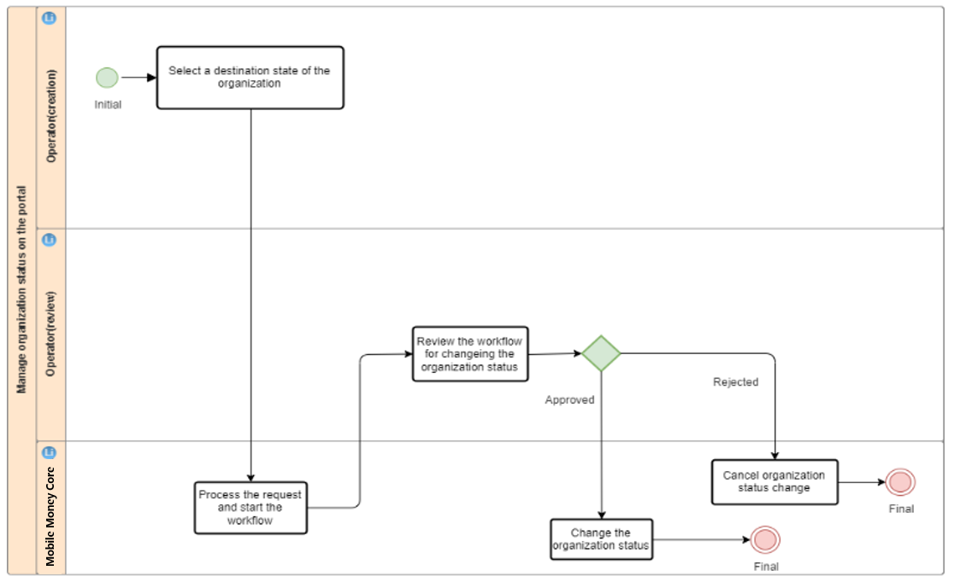

Whether organization status change needs an approval process depends on the workflow configuration. (Typically, approval process is required.) If organization status change does not need an approval process, the system directly changes the status of the organization after an organization status change request is submitted.

The process of changing the status of an organization through the API complies with the universal service process of the generic API. For changing the status of an organization through the API, whether an approval process is required depends on the workflow configuration. If yes, the request needs to be approved on the portal.

The process of changing the status of organizations in bulk is the same as that of other bulk tasks. An operator can upload a bulk file on the portal to create a bulk task of changing the status of organizations in bulk. During bulk organization status change, a single organization does not need an approval process. Whether organization status change needs an approval process depends on the workflow configuration. (Typically, approval process is required.)

### User Experience

Figure 1-5 shows the button for changing the organization status on the organization identity page.

Button for changing the organization status on the organization identity page

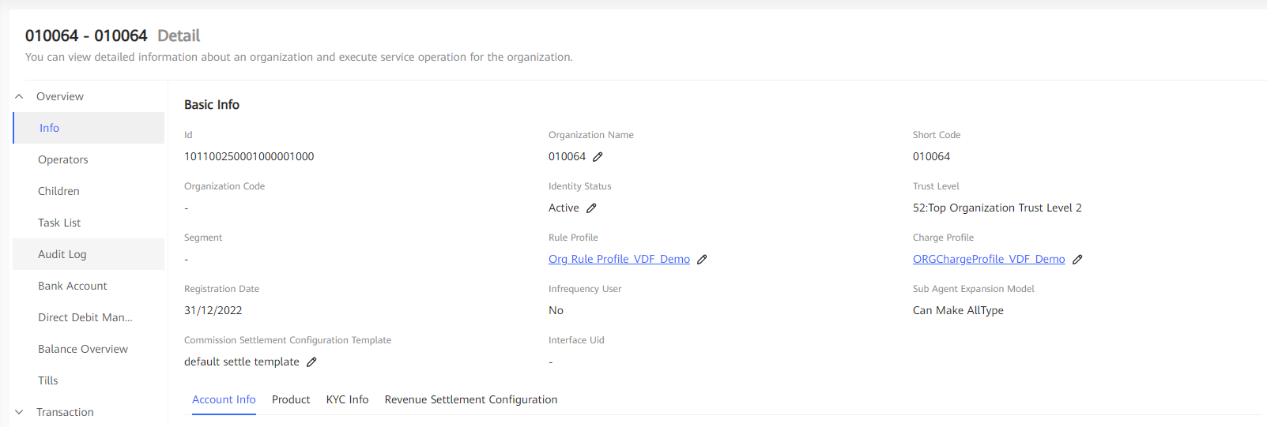

Figure 1-6 shows the dialog box for changing the organization status.

Dialog box for changing the organization status

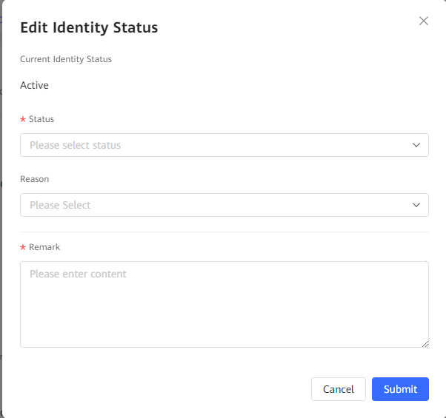

After receiving an organization status change request, the system creates a workflow and determines whether the request needs an approval process based on the workflow configuration. User experience of the approval process is the same as that of other workflows.

User experience of changing the status of an organization through the API is determined by the external system. The system determines whether the request needs to be approved based on the workflow configuration. If yes, the request needs to be approved on the portal and user experience is the same as that of changing the status of an organization on the portal.

Service experience of changing the status of organizations in bulk is the same as those of other bulk tasks.

### Configuration Points

Permission

The role of operator needs execution permissions named **Identity Management** > **Manage Identity** > **Organization** > **Change Organization Status** and **Identity Management** > **Manage Identity** > **Organization** > **View Basic Info** to manage organization's life cycle.

## Specifications

Technical Specifications

Table 3-2 describes status of an organization.

Status of an organization

| Status | Description | Remarks |
| --- | --- | --- |
| New | Indicates that the organization is newly created. | Organizations in this state cannot use any service. |
| Active | Indicates that the organization is normally activated. | Organizations in this state can normally use various services. |
| Suspended | Indicates that the organization is suspended. | Organizations in this state cannot initiate transactions but can receive transactions. |
| Frozen | Indicates that the organization is frozen. | Organizations in this state cannot initiate and receive transactions. |
| Close | Indicates that the organization is closed. | Organizations in this state cannot use any service. |
| Dormant | Indicates that the organization is long time inactive. | This organizations will be close after a special time pointed by SP. |

Table 3-3 describes organization status change and change rules.

Organization status change and change rules

| Old Status | New Status | Scenario and Rule |
| --- | --- | --- |
| New | Active | When an organization is registered, the organization enters the **New** state. After the registration is approved, the organization enters the **Active** state. If a registered organization does not need to be approved, the registered organization directly enters the **Active** state. |
| Active | Suspended | Based on service requirements, an operator can change the organization status from **Active** to **Suspended**. |
| Frozen | Based on service requirements, an operator can change the organization status from **Active** to **Frozen**. |
| Closed | Based on service requirements, an operator can change the organization status from **Active** to **Closed**.  Before closing an organization, the operator must:   * Check whether the organization has child organizations in **Active**, **Suspended**, or **Frozen** state. If yes, the operator cannot close the organization. * Check whether the balance of all accounts of the organization is zero. If the organization has an account whose balance is not zero, the operator cannot close the organization. * Check whether the organization has uncompleted transactions (including having vouchers with amounts). If yes, the operator cannot close the organization.   After closing an organization, the operator needs to:   * Close all tills of the organization. * Close all operators of the organization. * Close all accounts of the organization. |
| Suspended | Active | Based on service requirements, an operator can change the organization status from **Suspended** to **Active**. |
| Frozen | Based on service requirements, an operator can change the organization status from **Suspended** to **Frozen**. |
| Closed | The rule is the same as that of changing the transaction status from **Active** to **Closed**. |
| Frozen | Active | Based on service requirements, an operator can change the organization status from **Frozen** to **Active**. |
| Closed | The rule is the same as that of changing the transaction status from **Active** to **Closed**. |
| Dormant | Closed | This organizations will be close after a special time pointed by SP. |
| Closed | - | The **Closed** state is a final state and cannot be changed to other status. |

Standards Compliance

None

## Enhancements

None

## Reference

None

# Registering an Organization Operator

## Definition

In the Mobile Money system, not only individual customers but also some organizations must be registered. The organizations can be the agents who help SPs provide customer services (such as customer registration, deposit, and withdrawal), merchants that sell offerings, organizations that receive bill payment, and MNOs that receive Airtime Purchase. In the Mobile Money system, organization operations are performed by organization operators. Therefore, the organization operators need to be registered with the Mobile Money system to facilitate the management of organization operators' information and behavior.

## Benefits

Table 1-6 describes the benefits of this feature.

Benefits of this feature

| For... | Benefits |
| --- | --- |
| SPs | SPs can register various organization operators that participate in the Mobile Money system to manage them. With more organizations' participation in the Mobile Money system, the Mobile Money service scope is broadened and the Mobile Money customer benefits are increased, so that SPs can obtain more profits. |
| Individual customers | Individual customers can enjoy services provided by various organizations in the Mobile Money system. |
| Organizations | Organizations can participate in the Mobile Money system, provide services together with SPs, and share benefits, or improve the quality of other services for themselves. |

## Description

In the system, SP and organization operators can register an organization operator on the web portal, by bulk tasks, or through APIs.

During organization operator registration, the following operations must be performed:

* Specify the organization for the operator using a short code.
* Select the language preferred by the operator.
* Select an access channel (for example, the web, handset, or API channel) supported by the operator. The API channel and other two channels are mutually exclusive.
* Record the user name of the operator.
* Record the operator ID (only for handset access).
* Record organization KYC information, for example, the operator name, birthday, address, contact information, and certificate information. KYC fields to be recorded can be set based on sites.
* Specify the organization operator's transactions or operation limit rule profiles.
* Assign roles for the organization operator.

SP operators can create operators for all organizations. Organization operators can create operators only for themselves or child organizations.

## Requirements

Requirements on the System

This feature is a basic feature and the web portal is used to register organization operators. Interaction with external systems is not required.

To register organization operators through APIs, a third-party system must be provided to invoke Generic APIs through SOAP (over https).

Requirements on the Network

To register organization operators through APIs, the system must provide the SOAP (over https) interface for the third-party system.

## Impact on the System

Impact on the System Capacity

None

## Application Limitations

None

## Feature Interactions

Feature Dependencies

This feature depends on the Operator Role & Permission Control feature, because an operator belongs to a role.

Mutually Exclusive Features

None

## Technical Description

### Architecture

None

### Business Process

The following figure shows the process of registering organization operators on the portal.

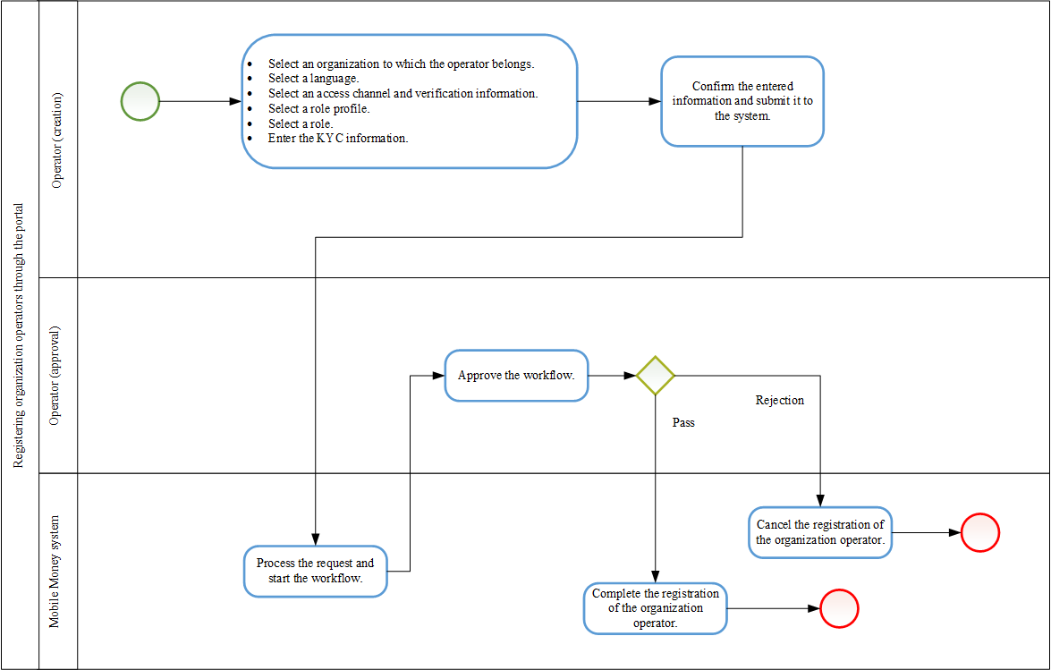

In the preceding process, the system determines whether approval is required (generally, approval is required) based on the workflow configuration. If approval is not required, after the organization operator submits the request, the system directly registers the organization operator.

The service process of registering organization operators through APIs complies with the common service process of Generic APIs. When APIs are used to register organization operators, the system determines whether approval is required based on the workflow configuration. If approval is required, the approval needs to be completed on the portal.

The service process of registering organization operators in batches using bulk tasks is the same as all other batch processing processes performed using bulk tasks. An operator uploads the file on the portal to create a bulk task to register organization operators in batches. During batch organization operator registration, organization operators are not approved one by one. For the entire bulk task, the system determines whether to perform approval based on the workflow configuration. Generally, approval is required.

### User Experience

1. Choose **Identity** > **Organization Operator** and click **Create**.
2. Configure **organization operator** information on the **Organization Operator** Info tab page.

Organization operator registration.

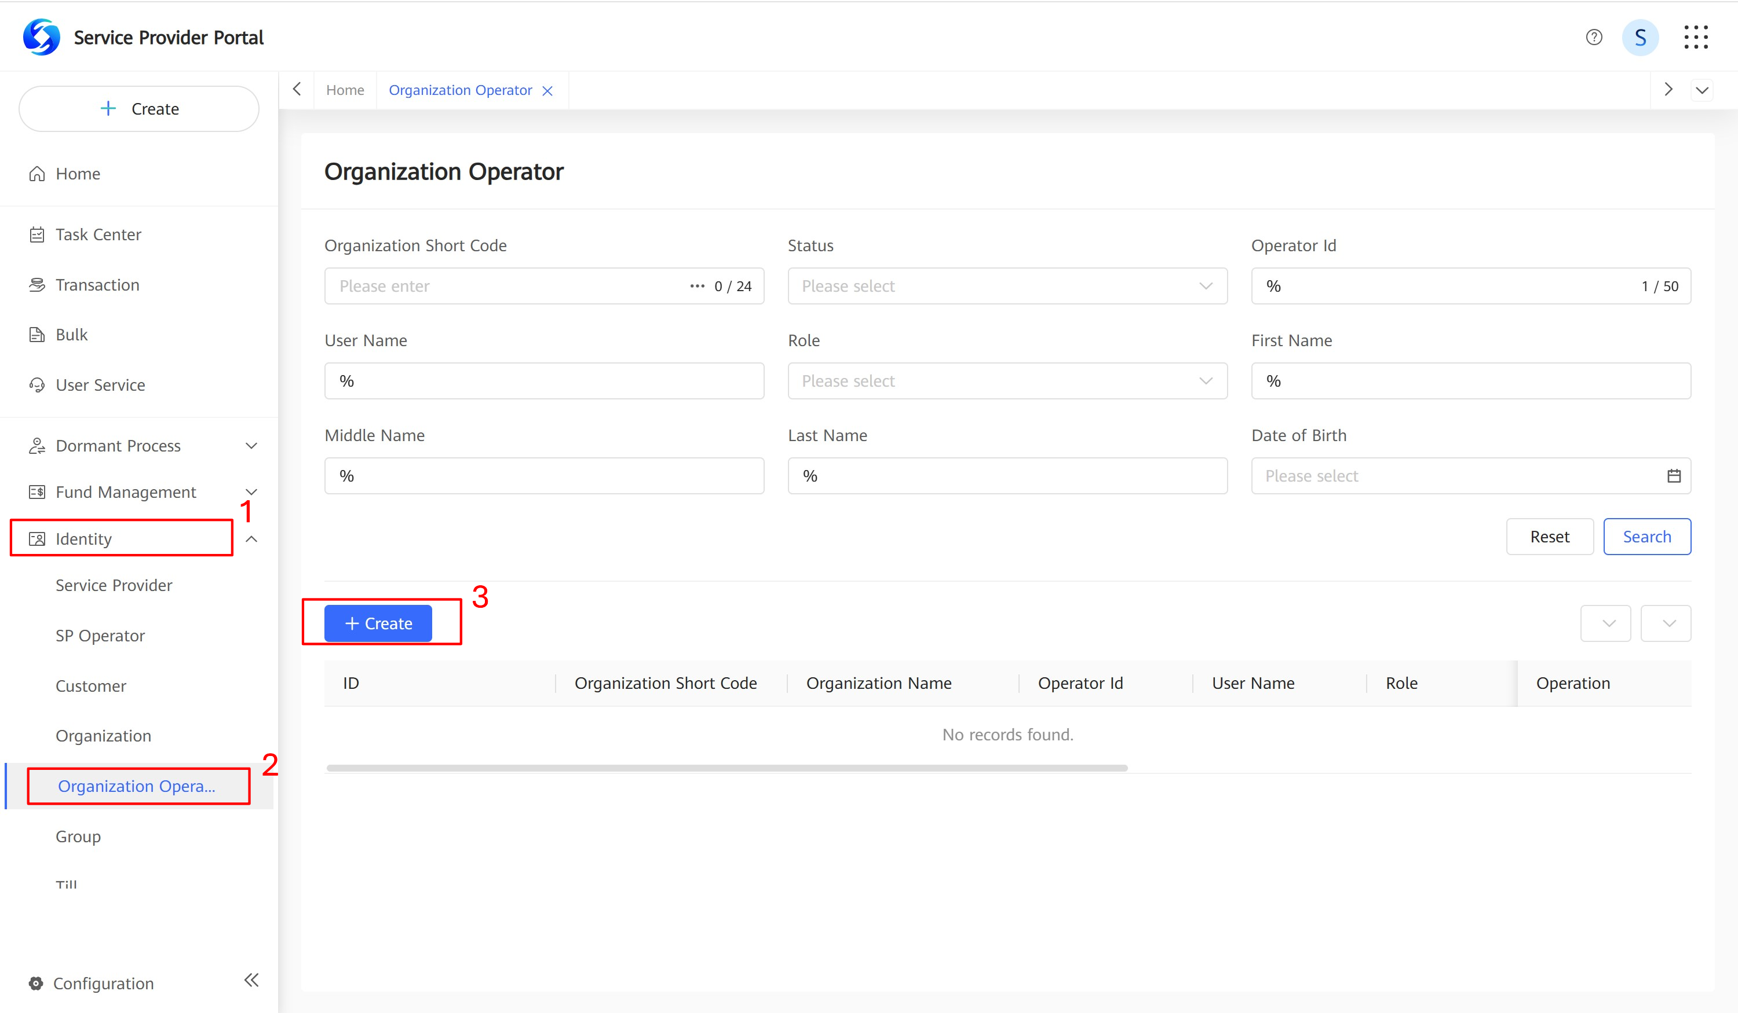

1. On the **Organization Operator Info** page, configure the basic information for the **operator**, and click **Next**, as shown in **Figure 3-2.**

Organization operator registration.

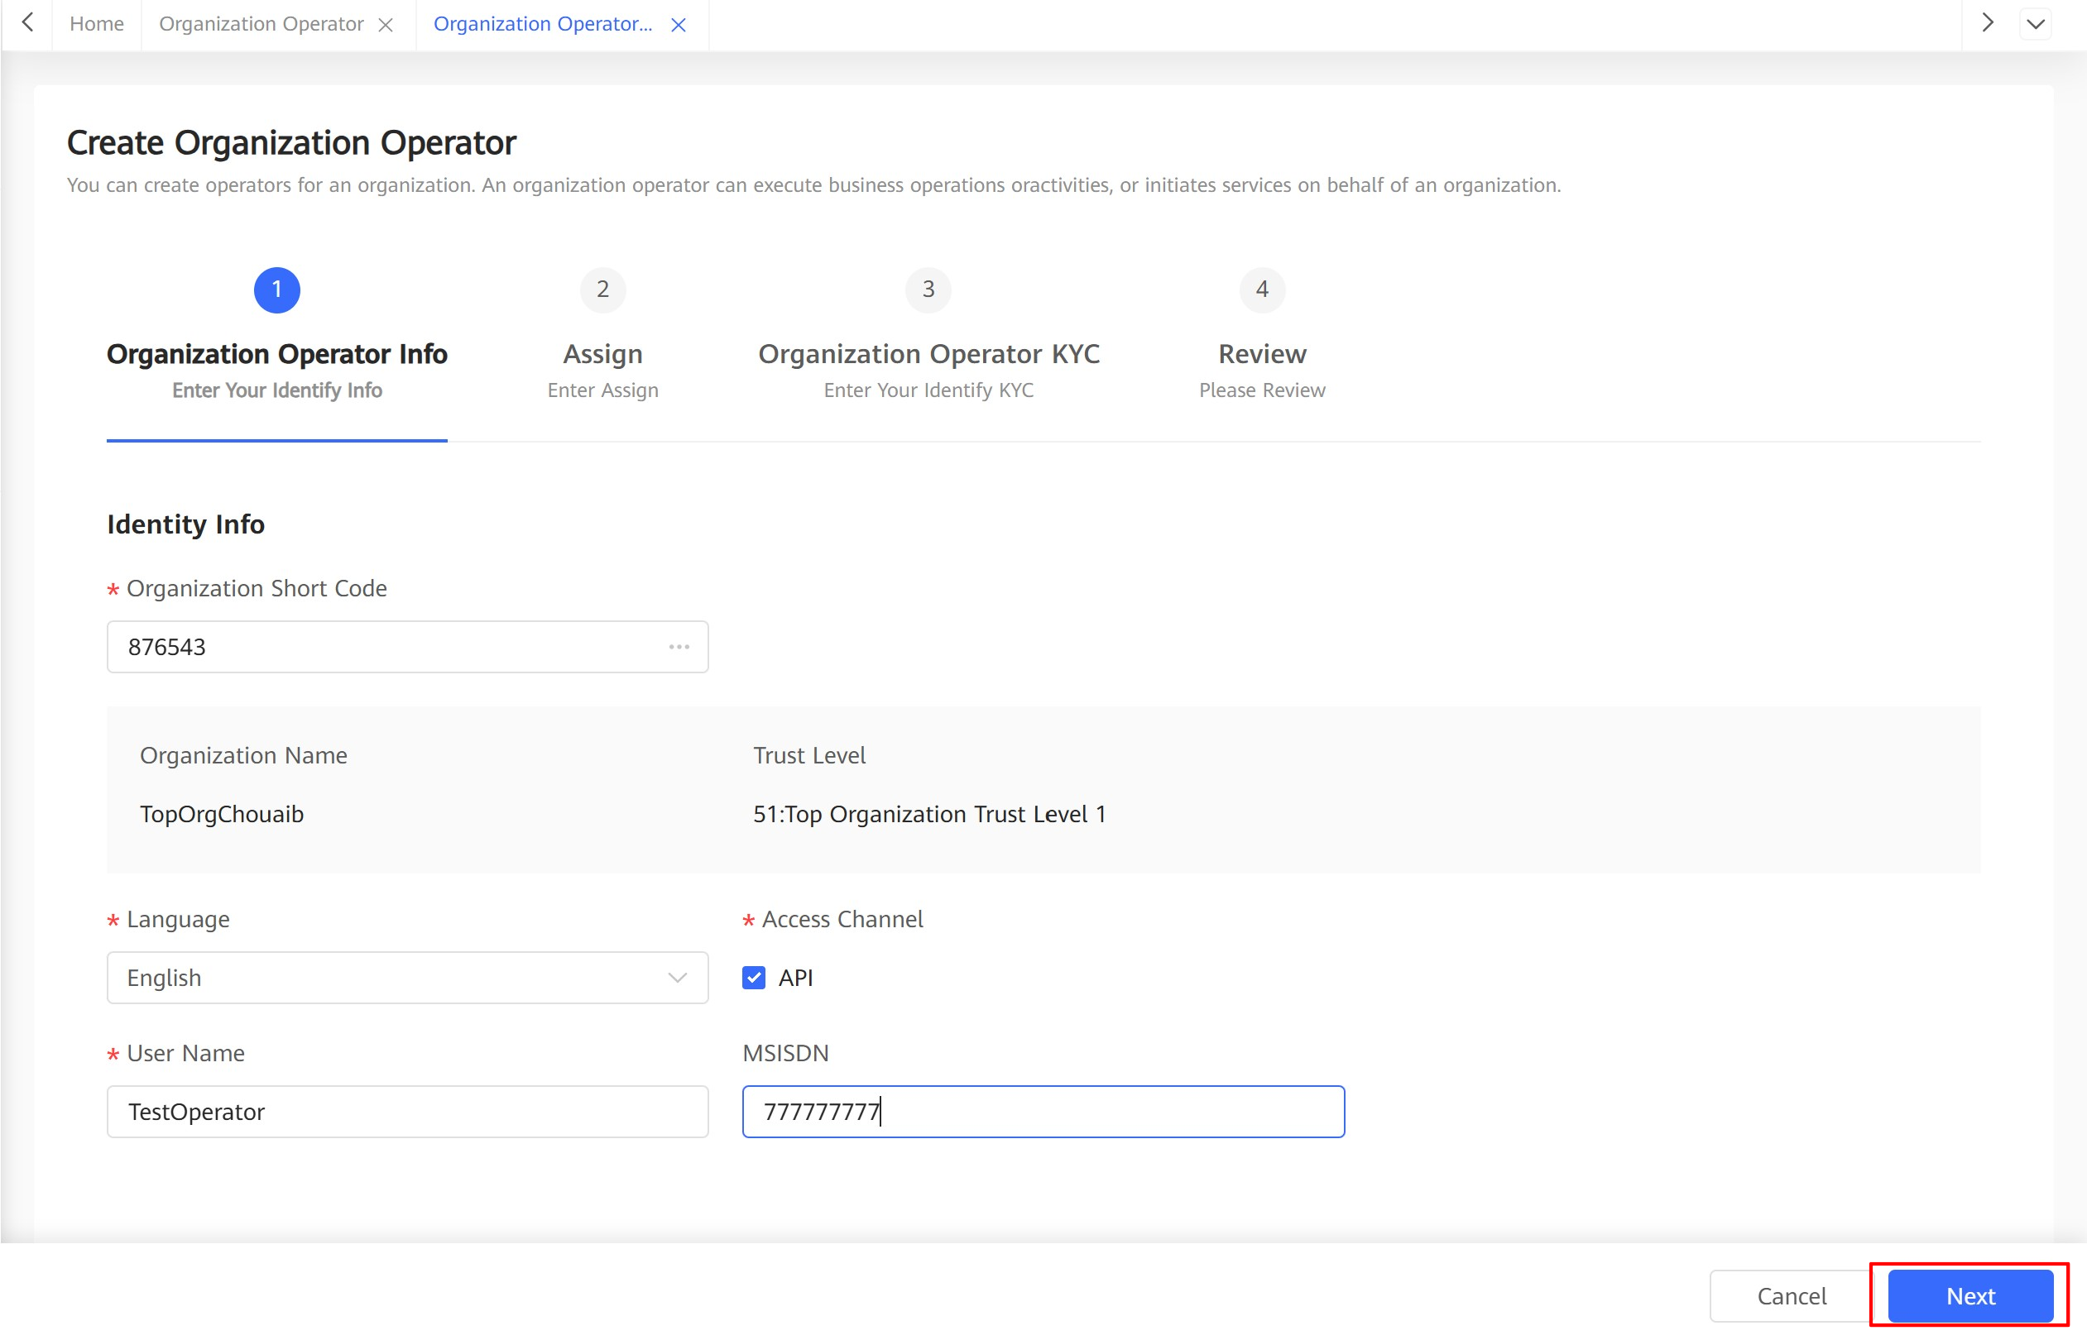

1. On the **Assign** page, configure the rule profile of the operator, click **Add** to select a role for the operator, and click **Next**.

Organization operator role assignment.

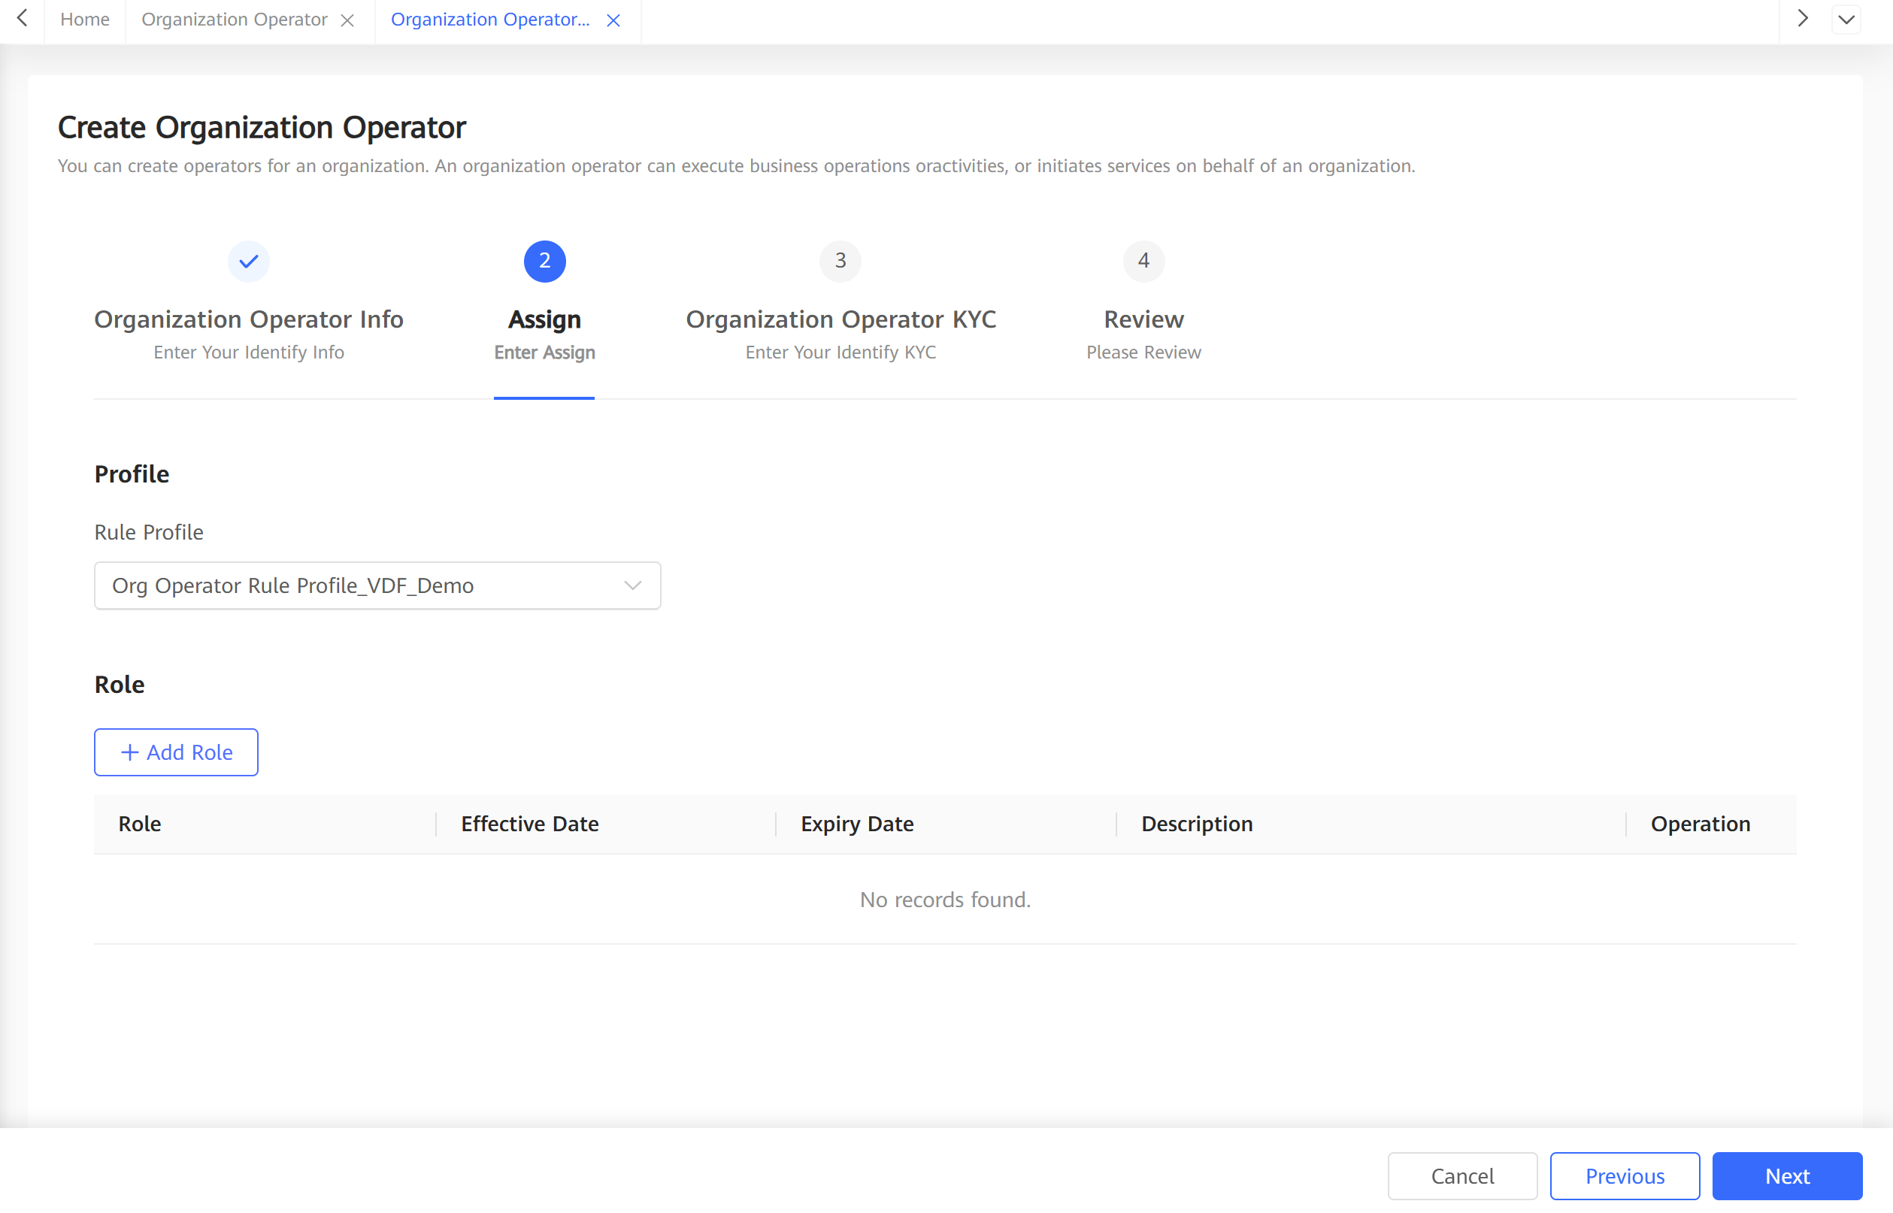

1. On the **KYC Info** page, enter the organization operator KYC information and click **Next**.

Organization Operator KYC information.

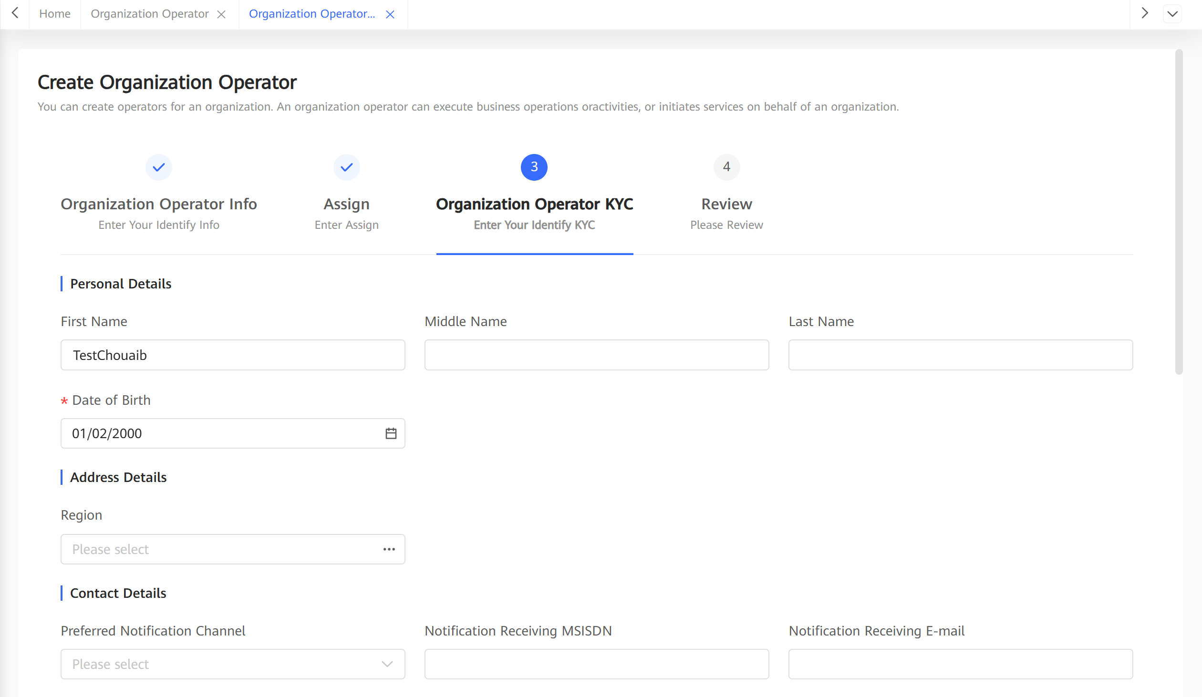

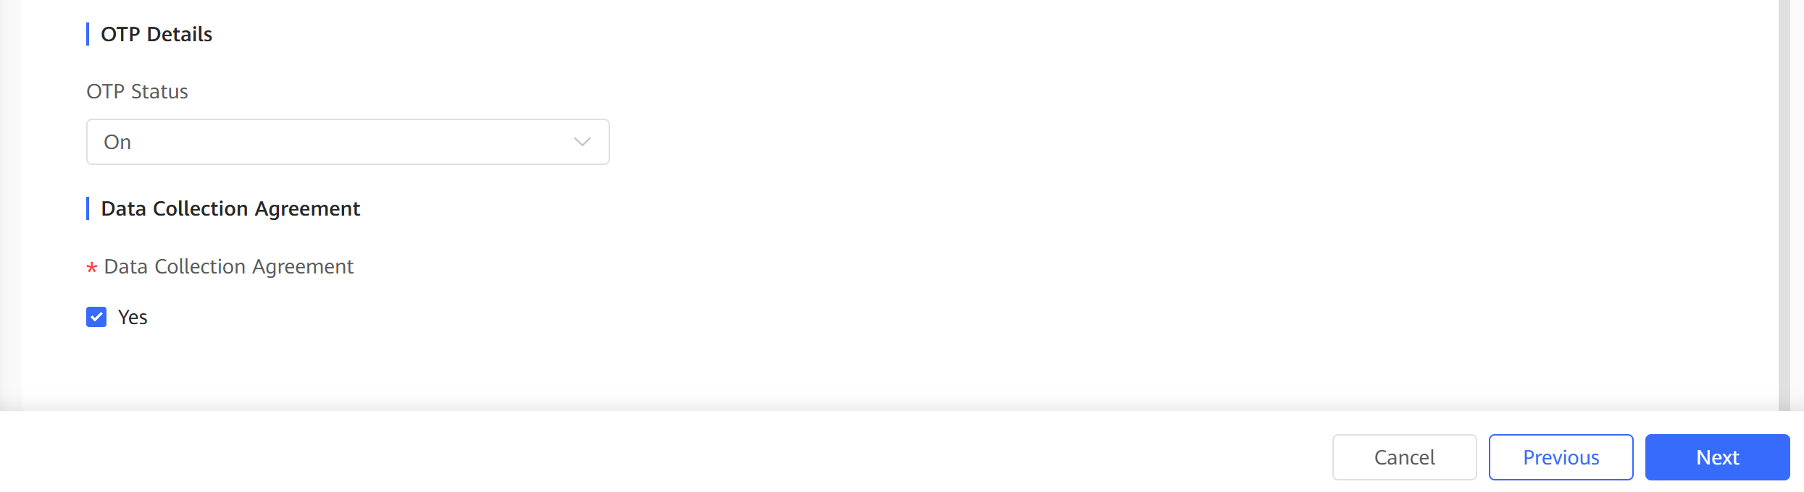

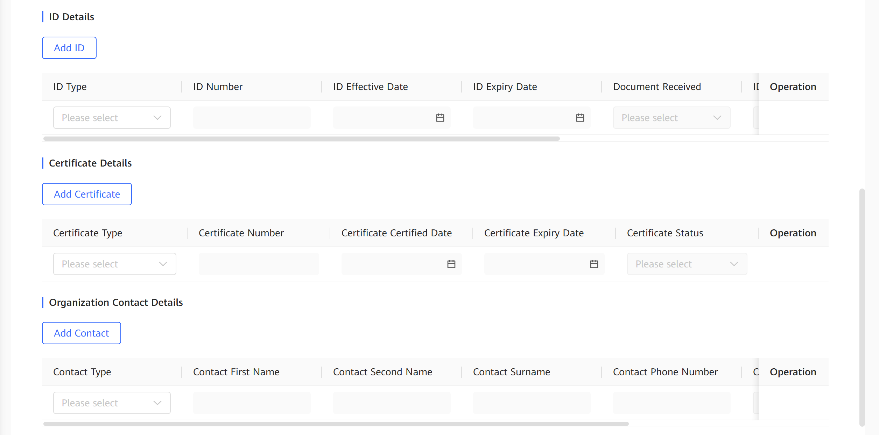

1. Confirm the organization operator information on the **Review** tab page and click **Submit**.
   1. Check all information configured
   2. Click **Submit**.

Organization Operator configuration review page.

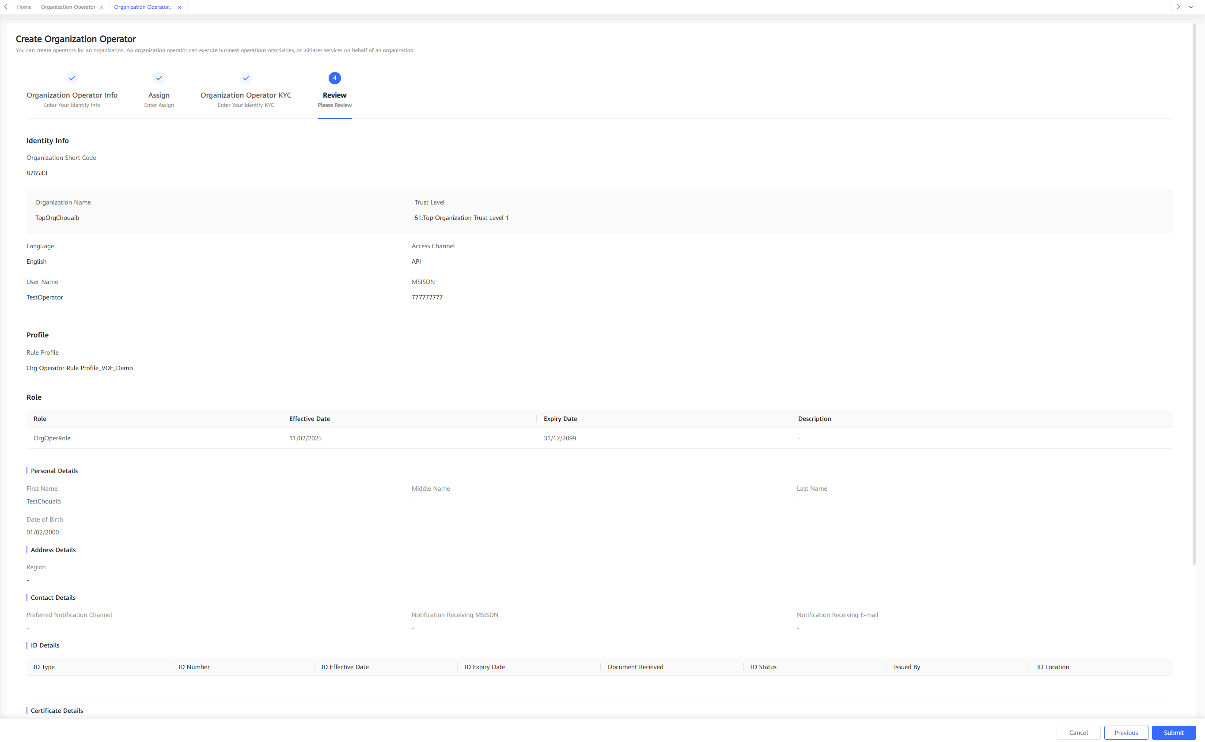xxxxx

* 1. After the organization operator creation request is submitted:
     + If manual approval is required, the organization operator enters the **New** state. After the request is approved, the organization operator status changes from **New** to **Pending Active**.
     + If no manual approval is required, the organization operator enters the **Pending Active** state.

After being created, the organization operator is in **Pending Active** state. The system sends a registration success notification to the operator.

### Configuration Points

Permission

The role of operator needs execution permissions named **Create Organization Operator** to register an organization operator.

## Specifications

Technical Specifications

Table 4-2 describes organization information related to organization operator registration and the service rules.

Organization information related to organization operator registration and the service rules

| Organization Information | Service Rule |
| --- | --- |
| Organization short code | ID of an organization to which the operator belongs, which is mandatory. The short code of any unclosed organization in the system cannot be repeated. |
| Language | Preferred language of the operator, which is the language used when the operator accesses the system and used for notification. |
| Access channel | Supported access channel, including the web, handset, and API, which is mandatory. At least one access channel must be selected. |
| Operator ID | Operator ID used for authentication when an operator uses the handset access channel, which is mandatory for the handset channel. |
| User name | User name used for login to the portal through the web channel, which is mandatory for the web and API channels. |
| Operator rule profile | Rule profile that must be set for an organization operator to be registered. The rule profile contains a series of limit rules, which specifies the limits on the operator operations. |
| Role | Role of an operator. Permission has been preconfigured for the role to control the operator permission. Multiple roles can be specified for an operator. |
| KYC | Function-relevant KYC fields preconfigured in the system. The fields are used or not used based on the function requirements.  Some KYC fields can be defined based on the site service requirements.  KYC fields configured for an operator can be set to optional or mandatory. |
|  |  |

Organization Operator KYC infos.

|  |  |
| --- | --- |
| **Parameter** | **Description** |
| **Personal Details** | |
| First Name | First name of an organization operator. |
| Middle Name | Middle name of an organization operator. |
| Last Name | Last name of an organization operator. |
| Date of Birth | Date of birth of an organization operator. |
| Gender | Gender of an organization operator. |
| Email | Email of an organization operator. |
| Preferred Contact Phone Number | Priority contact number of an organization operator. |
| Nationality | Nationality of an organization operator. |
| **Contact Details** | |
| Preferred Notification Channel | Preferred notification channel. The options are as follows:   * + **SMS**   + **Email** |
| Notification Receiving MSISDN | Mobile number for receiving notifications. This parameter is mandatory only when **Preferred Notification Channel** is set to **SMS**. |
| Notification Receiving E-MAIL | Email address for receiving notifications. This parameter is mandatory only when **Preferred Notification Channel** is set to **Email**. |
| **ID Details** | |
| ID Type | ID type. |
| ID Number | ID. |
| ID Expiry Date | ID expiration date. |

Standards Compliance

None

## Enhancements

None

## Reference

None

# Managing the Organization Operator Life Cycle

## Definition

Organization operators are identities that participate in Mobile Money services. During service operation of the Mobile Money system, organization operator life cycles need to be managed, including updating the operator status.

## Benefits

Table 1-8 describes the benefits of this feature.

Benefits of this feature

| For... | Benefits |
| --- | --- |
| SP | SPs can manage the status of organization operators based on service requirements during Mobile Money service operation. When there are risks, SPs can suspend the operators to avoid risks, improve the service quality, and reduce loss. After the risks are eliminated, organization operators can be activated again. When operators are not responsible for Mobile Money services or all the organizations exit, the corresponding organization operators can be closed in the system. |
| Individual customers | The organization operator life cycle can be managed to construct a better service ecosystem. |
| Organizations | Organization operators are the key role to perform service operations for organizations. After organization operator life cycles are managed, organizations can better control the operators that belong to the organizations to prevent service risks, ensure proper running of organization services, and provide a good payment ecosystem. |

## Description

In the system, SP and organization operators can manage the status of an organization on the web portal, by bulk tasks, or through APIs.

SP operators can manage the status of all organization operators in the system. An organization operator can manage the status only of the organization and its child organization operators.

## Requirements

Requirements on the System

This feature is a basic feature and the web portal is used to manage the status of organization operators. Interaction with external systems is not required.

To manage the status of organization operators through APIs, a third-party system must be provided to invoke Generic APIs through SOAP (over https).

Requirements on the Network

To manage the status of organization operators through APIs, the system must provide the SOAP (over https) interface for the third-party system.

## Impact on the System

Impact on the System Capacity

None

## Application Limitations

None

## Feature Interactions

Feature Dependencies

Organization operators are created based on the feature of registering organization operators.

In addition, during organization operator creation, the status of organization operators must be changed during approval.

Mutually Exclusive Features

None

## Technical Description

### Architecture

None

### Business Process

The following figure shows the process of managing the status of organization operators on the portal.

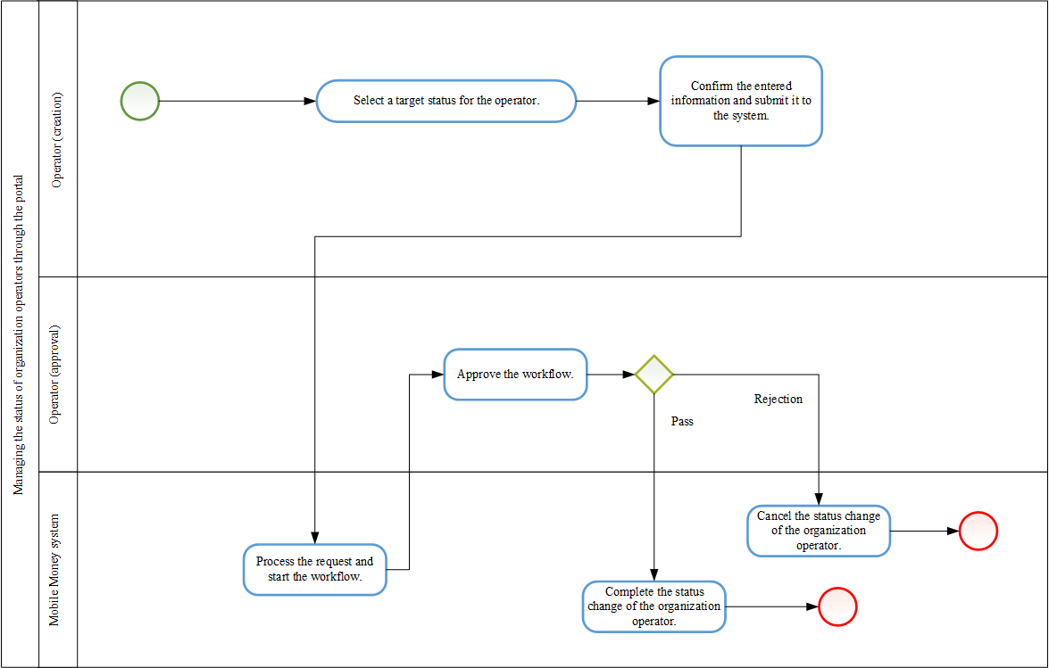

In the preceding process, the system determines whether approval is required (generally, approval is required) based on the workflow configuration. If approval is not required, after the organization operator submits the request, the system directly changes the status of the organization operator.

The service process of changing the status of organization operators through APIs complies with the common service process of Generic APIs. When APIs are used to manage the status of organization operators, the system determines whether approval is required. If approval is required, the approval needs to be completed on the portal.

The service process of changing the status of organization operators in batches using bulk tasks is the same as all other batch processing processes performed using bulk tasks. An operator uploads the file on the portal to create a bulk task to change the status of organization operators in batches. During batch organization operator status change, organization operators are not approved one by one. For the entire bulk task, the system determines whether to perform approval based on the workflow configuration. Generally, approval is required.

### User Experience

Shows operator life cycle management.

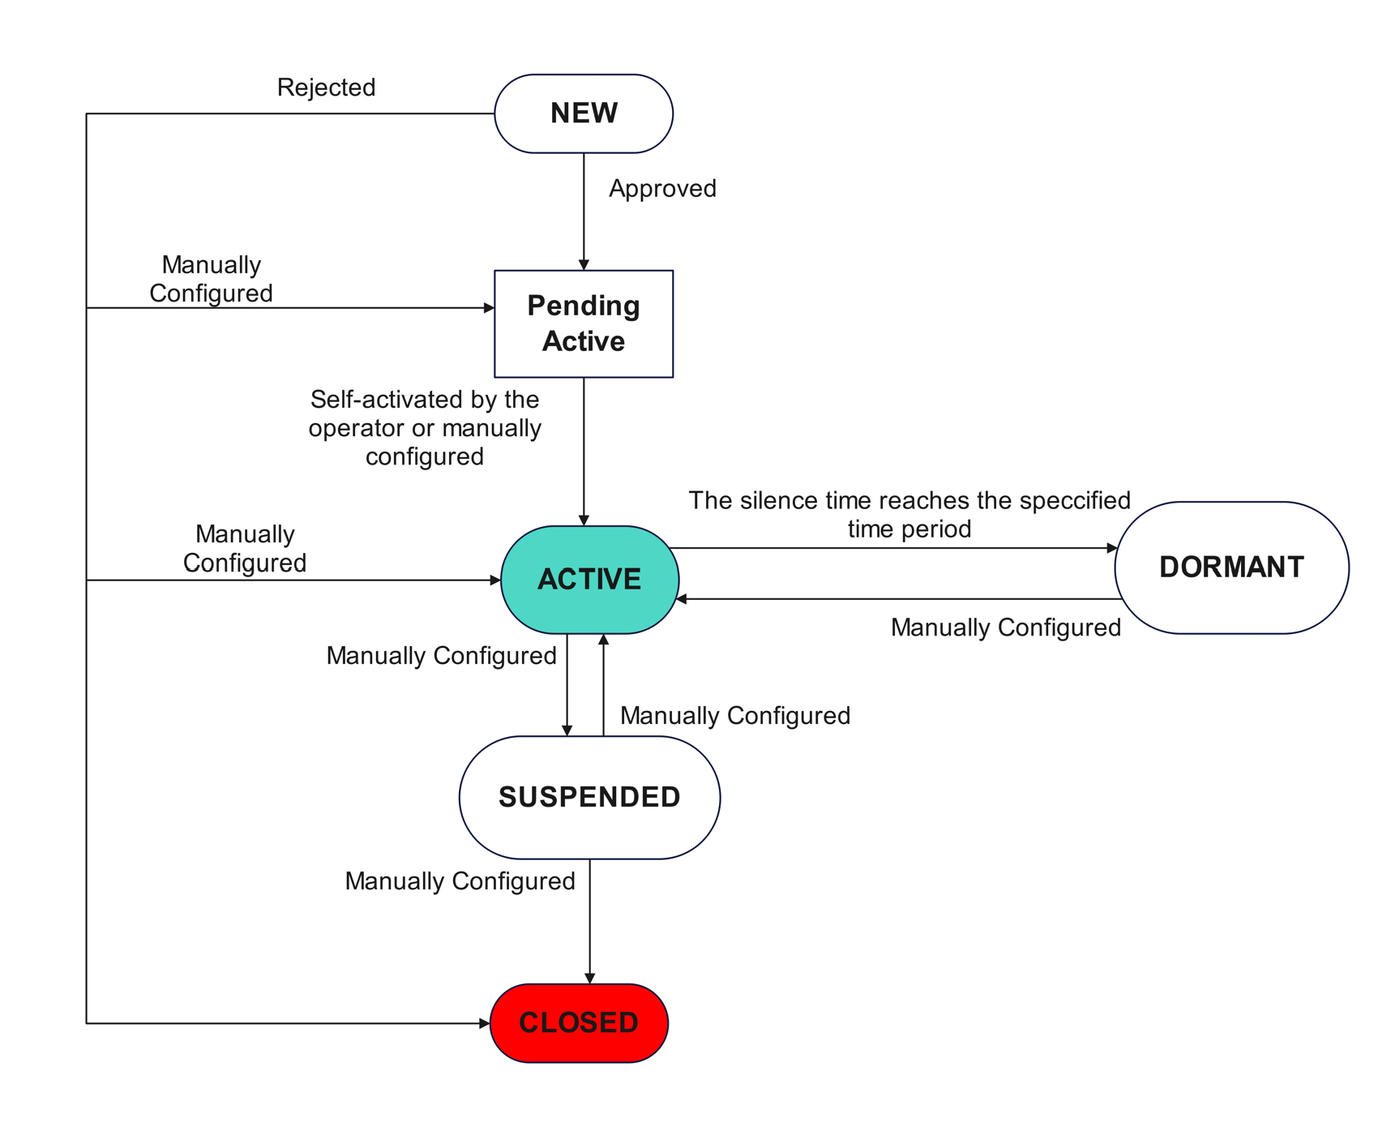

To change the status of organization operators on the portal, an organization operator clicks the button next to **Identity Status**, as shown in the following figure.

Shows the Edit Button to edit organization operator **Identity State**.

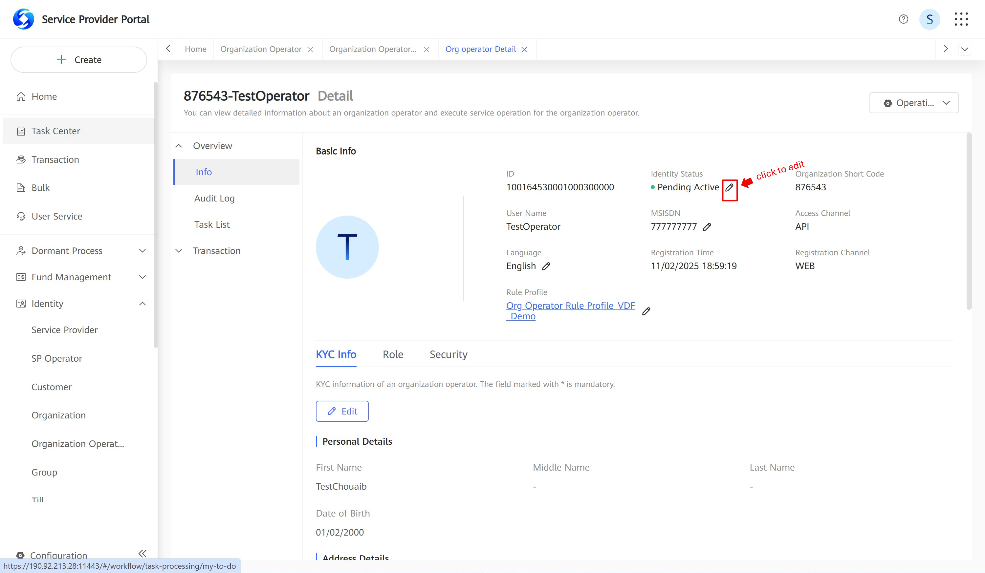

In the dialog box that is displayed, as shown in the following figure, the organization operator selects a value from the **Identity Status** drop-down list box.

Organization operator identity status editing.

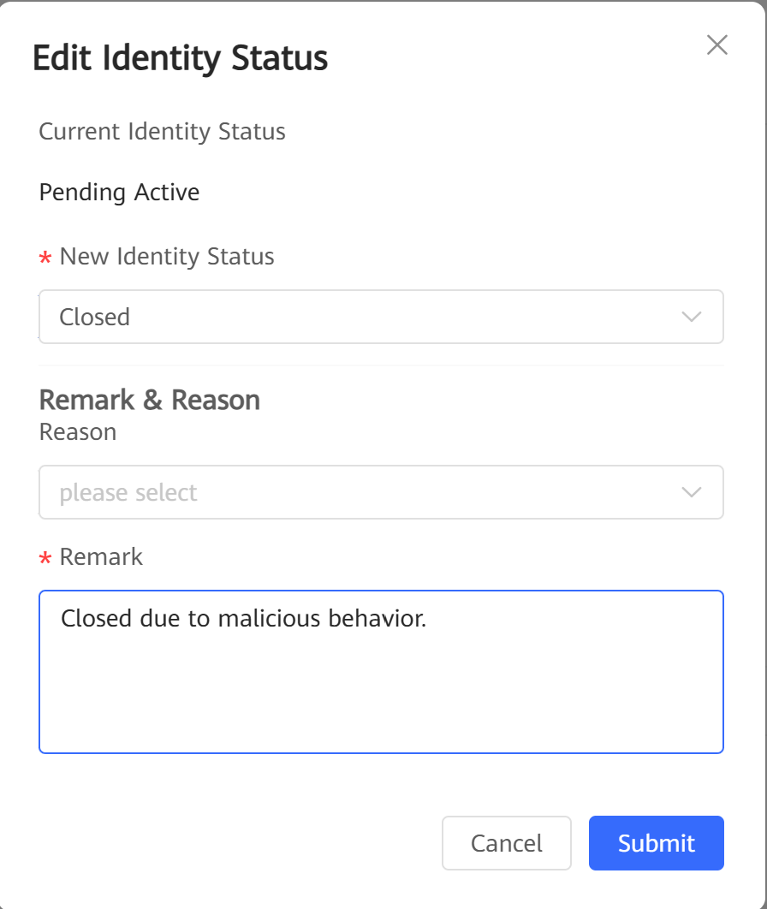

After the organization operator submits a request to the system background, the system creates a workflow and determines whether approval is required based on the workflow configuration. The service process of workflow task approval is the same as that of other workflow tasks.

The service process of changing the status of organization operators through APIs is determined by external systems. The system determines whether approval is required based on the workflow configuration. If approval is required, the approval needs to be completed on the portal. The service process is the same as that of approval of organization operator status change on the portal.

The service process of changing the status of organization operators in batches using bulk tasks is the same as all other batch processing processes performed using bulk tasks.

### Configuration Points

Permission

The role of operator needs execution permissions named **Manage Identity** > **Organization Operator** > **Change Operator Status** to manage an organization operator life cycle. And if operator wants to manage organization operator life cycle via web, he or she also needs execution permissions named **Manage Identity** > **Organization Operator** > **Query Basic Info**.

## Specifications

Technical Specifications

Table 1-9 describes the possible status of organization operators.

Possible status of organization operators

| Operator Status | Description | Impact |
| --- | --- | --- |
| New | If an operator needs to be approved, the operator enters the **New** state after being created. If an operator does not need to be approved, the operator enters the **Pending Active** state after being created. | The operator cannot perform any operations but can be found. |
| Pending Active | * An SP operator enters the **Pending Active** state after being approved. * An organization operator enters the **Pending Active** state after being approved. | The operator cannot perform any operations but can be found. |
| Active | An operator enters the **Active** state after being activated. | The operator is in the normal state and can perform any operation. |
| Suspended | A suspended operator cannot perform any operations. | The operator cannot perform any operations. |
| Closed | A closed operator cannot perform any operations. | The operator cannot perform any operations but can be found. |

Table 1-10 describes the allowed organization status and the change rules.

Allowed organization status and change rules

| Operator Status | | Status Change |
| --- | --- | --- |
| From | To | - |
| New | Pending Active | An operator is in the **New** state upon creation. After approval, an SP operator enters the **Active** state and an organization operator enters the **Pending Active** state. |
| Pending Active | Active | An organization operator can activate themselves by modifying the security credential. |
| Closed | An authorized operator can manually change the status of other operators from **Pending Active** or **Suspended** to **Closed**. |
| Active | Suspended | An authorized operator can manually change the status of other operators from **Active** to **Suspended**.  The status changes to **Suspended** when the number of voucher code verification failures reaches the maximum. |
| Closed | An authorized operator can manually change the status of other operators from **Active** to **Closed**. |
| Suspended | Active | An authorized operator can manually change the status of other operators from **Suspended** to **Active**. |
| Closed | An authorized operator can manually change the status of other operators from **Suspended** to **Closed**. |

Standards Compliance

None

## Enhancements

None

## Reference

None

# Organization KYC Management

## Definition

Organizations are identities that participate in services of the Mobile Money system. The Mobile Money system needs to record various information about organizations, including configuration information related to system service processing and customer information required for operation. The information is defined as extensible KYC fields in the Mobile Money system.

Some common KYC fields and KYC fields related to some functions are preset in the system. Local markets can use or not use these KYC fields based on the site requirements. Local markets can also define some new KYC fields for organizations based on the site requirements.

When an organization is registered, KYC fields need to be set for the organization. During operation, KYC field values of the organization can be changed.

## Benefits

Benefits of this feature

| For... | Benefits |
| --- | --- |
| SP | During operation of the Mobile Money system, the SP can manage various information about organizations based on service requirements, including configuration information related to system service processing and identity information required for operation. |
| Individual customers | N/A |
| Organizations | After the SP record information about organizations, the organizations can enjoy better system functions and customer services. |

## Description

The Mobile Money system allows SP and organization operators to manage KYC information about an organization through channels such as the web, bulk, and API.

When registering an organization, an operator needs to enter the KYC information about the organization and determine the trust level and segment of the organization, restricting the assignment of products, charge profiles, and rule profiles of the organization.

If the trust level and segment of an organization change during KYC information modification, the system needs to automatically change information about products, charge profiles, and rule profiles of the organization and notify the organization of the change.

SP operators can manage KYC information about all top-level organizations and child organizations in the system. Organization operators can manage only KYC information about child organizations of their own organizations.

## Requirements

Requirements on the System

This feature is a basic feature and does not involve interaction with external systems if organization KYC information is modified on the web portal.

If organization KYC information is modified through the API, a third-party system needs to be provided to invoke the generic API of the Mobile Money system using the SOAP (over HTTPS) protocol.

Requirements on the Network

When organization KYC information can be modified through the API, the SOAP (over HTTPS) API must be exposed to third-party systems.

## Impact on the System

None

## Application Limitations

None

## Feature Interactions

Feature Dependencies

This feature depends on the Organization Registration feature. This feature also depends on the Organization Product Assignment, Charging Management, and Limit Configuration features if products, charge profiles, and rule profiles are changed due to the trust level or segment change during KYC information modification.

This feature depends on the KYC Definition and Management feature too.

Mutually Exclusive Features

None

## Technical Description

### Architecture

None

### Business Process

Figure 6-1 shows the process of modifying organization KYC information on the portal.

Process of modifying organization KYC information on the portal

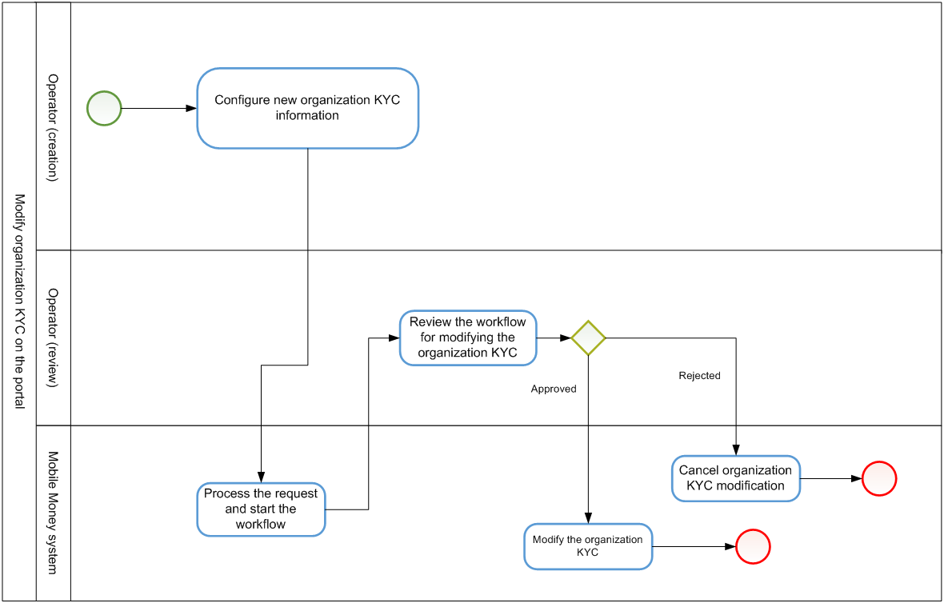

Whether organization KYC information modification needs an approval process depends on the workflow configuration. (Typically, approval process is required.) If organization KYC information modification does not need an approval process, the system directly modifies KYC information about the organization after an organization KYC information modification request is submitted.

The process of modifying KYC information about an organization through the API complies with the universal service process of the generic API. For modifying KYC information about an organization through the API, whether an approval process is required depends on the workflow configuration. If yes, the request needs to be approved on the portal.

The process of modifying KYC information about organizations in bulk is the same as those of other bulk tasks. An operator can upload a bulk file on the portal to create a bulk task of modifying KYC information about organizations in bulk. During bulk organization KYC information modification, the request to modify a single organization does not need an approval process. Whether organization KYC information modification needs an approval process depends on the workflow configuration. (Typically, approval process is required.)

### User Experience

Figure 6-2 shows the button for modifying organization KYC information on the organization identity page.

* + - 1. Choose **Identity** > **Organization** and put the **organization short code**, then click **search** as shown in the figure 6-2.

Button for modifying organization KYC information on the organization identity page

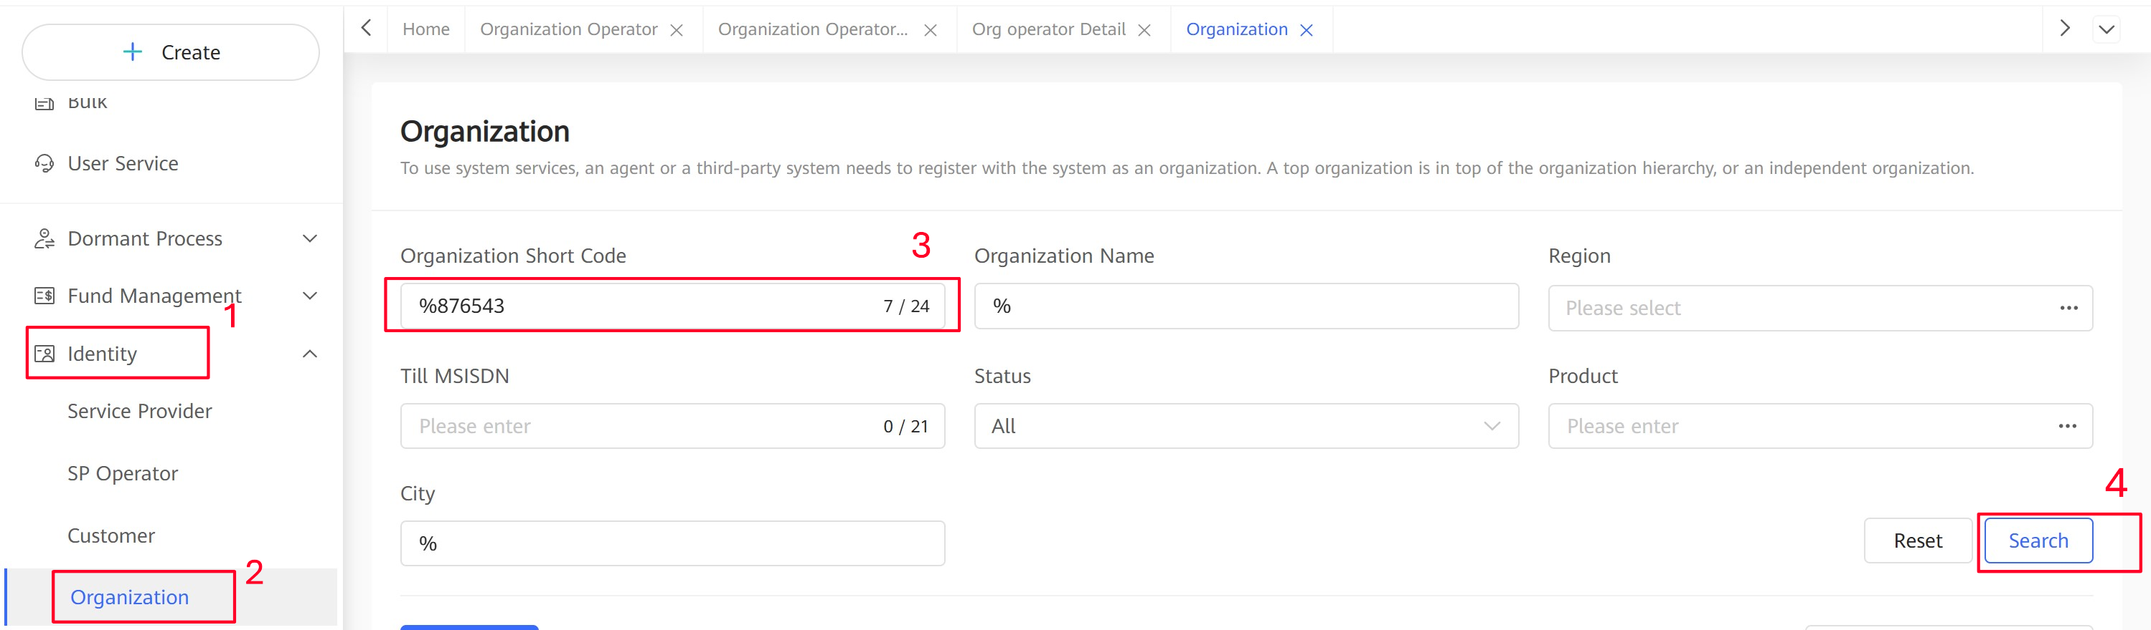

* + - 1. And then **Details**.



* + - 1. Then **KYC Info** tab.

Figure 6-3 shows the page for modifying KYC information about an organization.

Page for modifying KYC information about an organization.

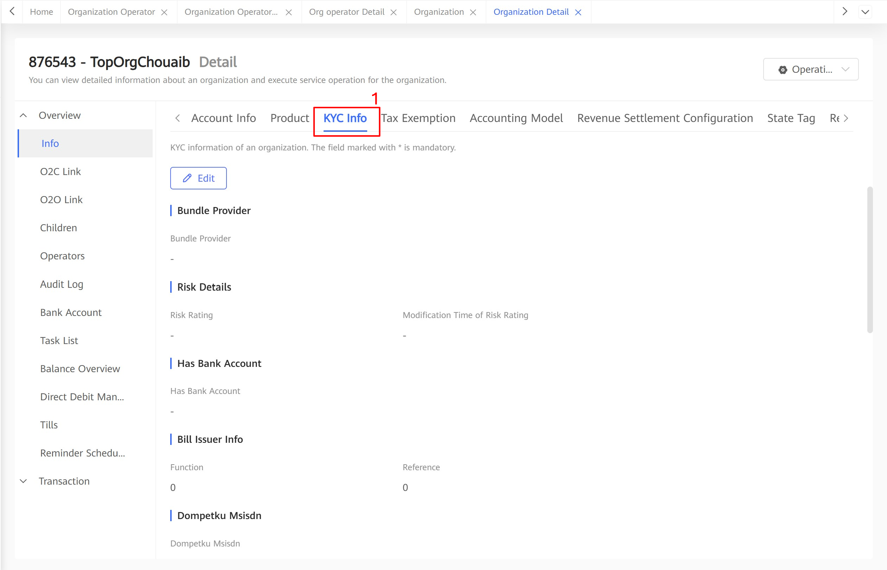

After modifying related KYC fields, the operator can submit a modification request to the Mobile Money system. When receiving the request, the Mobile Money system verifies the validity of KYC field values, checks whether the trust level and segment are modified based on the KYC field values, and checks whether products, charge profiles, and rule profiles are changed. Then, the Mobile Money system sends validation errors or associated changes to the operator for confirmation.

When the validation is passed and the operator confirms the modification, the system creates a workflow and determines whether an approval process is required for the modification based on the workflow configuration. User experience of the approval process is the same as that of other workflows.

User experience of modifying KYC information of an organization through the API is determined by the external system. The system determines whether the request needs to be approved based on the workflow configuration. If yes, the request needs to be approved on the portal and user experience is the same as that of modifying KYC information about an organization on the portal.

User experience of modifying KYC information about organizations in bulk is the same as those of other bulk tasks.

### Configuration Points

Permission

The role of operator needs execution permissions named **Manage Identity** > **Organization** > **Change KYC** to change an organization KYC. And if operator wants to manage organization KYC via web, he or she also needs execution permissions named **Manage Identity** > **Organization** > **Query Basic Info**.

## Specifications

Technical Specifications

* Organization KYC field setting

Table 1-12 describes organization KYC fields preset in the Mobile Money system. Local markets can use or not use these fields based on the service requirements.

Organization KYC fields preset in the Mobile Money system

| KYC Group | KYC Field | Remarks |
| --- | --- | --- |
| Address Details | Address Line 1 | - |
| Address Line 2 | - |
| Address Line 3 | - |
| City | - |
| Post Code | - |
| Region | A multi-level region list can be configured in the system. This KYC field is set by selecting a value from the tree view. |
| Risk Details | Risk Rating | The customer risk level is typically obtained through analysis of the AML system or other external systems and updated to the Mobile Money system for operators' reference. |
| Modification Time of Risk Rating | This KYC field cannot be modified. The system automatically records the last modification time of the **Risk Rating** field. |
| Contact Details | Preferred Notification Channel | This KYC field indicates the channel for sending notifications to organizations. The options are **SMS** and **E-mail**. |
| Notification Receiving MSISDN | This KYC field is mandatory when **Preferred Notification Channel** is set to **SMS**. |
| Notification Receiving E-mail | This KYC field is mandatory when **Preferred Notification Channel** is set to **E-mail**. |
| Preferred Notification Language | - |
| Certificate Details | Certificate Type | - |
| Certificate Number | - |
| Certificate Certified Date | - |
| Certificate Expiry Date | - |
| Organization Contact Details | Contact Type | - |
| Contact First Name | - |
| Contact Second Name | - |
| Contact Surname | - |
| Contact Phone Number | - |
| Contact Email | - |
| Contact ID Type | - |
| Contact ID Number | - |
| Bank Account Details | Currency | - |
| Bank | - |
| Bank Branch | - |
| Bank Account Name | - |
| Bank Account Number | - |
| Interoperability | Partner SP | - |
| PGW KYC | Business Mode | - |
| Accounting Mode | - |

Multiple rows of value can be specified for the KYC fields **Certificate Details**, **Organization Contact Details**, and **Bank Account Details** in the preceding table. The system provides a list for setting the KYC field **Certificate Details**, **Organization Contact Details**, or **Bank Account Details**. The operator can configure multiple rows in the list. Only one value can be specified for other KYC fields in the preceding table.

In addition to use the preset KYC fields, a local market can also define KYC groups and KYC fields based on the service requirements. However, a local market can define only single-value KYC fields and cannot add KYC fields to the group of multi-row-value KYC fields.

* Organization trust level configuration

Multiple trust levels applicable to organizations are defined in the Mobile Money system. Trust levels are configured for top-level organizations and child organizations independently.

The trust level is an integer ranging from 1 to 100. A larger number indicates a higher trust level. In addition, the trust level also has attributes such as name and description.

During trust level configuration, a group of KYC fields must be selected. For an identity subtype (for example, the top-level organization or child organization), the KYC fields required for a higher trust level must include the KYC fields required for all lower trust levels.

During organization registration and KYC information modification, the system evaluates all the met trust levels whose required KYC fields are all set according to the preceding configuration, and then select the highest trust level as the final organization trust level.

* Organization segment configuration

Multiple segments applicable to organizations are configured in the Mobile Money system. Segments are configured for top-level organizations and child organizations independently.

During segment definition, the operator must select a single-value KYC field applicable to this type of identity. The selected KYC field is called the segment type. One or more segments can be defined for a segment type. The value range of the KYC field corresponding to the segment type must be configured for each segment.

During organization registration and KYC information modification, the system determines all the organization segments based on the organization KYC information based on the preceding configuration. An organization can have multiple segments. All segments meeting the KYC setting requirements are specified as the organization segments.

* Assignment rules related to the trust level and segment

Table 1-13 describes assignment rules of products, charge profiles, and rule profiles for different trust levels and segments.

Assignment rules

| Item | Assignment Rule |
| --- | --- |
| Product | The applicable product range can be defined for each trust level. The applicable product range of a higher trust level must include applicable product ranges of all lower trust levels.  Zero to more default products can be defined for each trust level.  Zero to more default products can be defined for each segment of a trust level.  The default products must be in the applicable product range of the trust level. |
| Product charge profile | The following information can be configured for each organization product:  An applicable product charge profile range needs to be defined for each trust level. The applicable product charge profile range of a higher trust level must include applicable product charge profile ranges of all lower trust levels.  A default product charge profile can be defined for each trust level.  A default product charge profile can be defined for each segment of a trust level. The segment type priority also needs to be configured. If segments of multiple segment types exist, the segment type priority is used to determine the default product charge profile.  The default product charge profile must be in the applicable product charge profile range of the trust level. |
| Organization charge profile | The applicable organization charge profile range needs to be defined for each trust level. The applicable organization charge profile range of a higher trust level must include applicable organization charge profile ranges of all lower trust levels.  A default organization charge profile can be defined for each trust level.  A default organization charge profile can be defined for each segment of a trust level. The segment type priority also needs to be configured. If segments of multiple segment types exist, the segment type priority is used to determine the default organization charge profile.  The default organization charge profile must be in the applicable organization charge profile range of the trust level. |
| Organization rule profile | The applicable organization rule profile range needs to be defined for each trust level. The applicable organization rule profile range of a higher trust level must include applicable organization rule profile ranges of all lower trust levels.  A default organization rule profile can be defined for each trust level.  A default organization rule profile can be defined for each segment of a trust level. The segment type priority also needs to be configured. If segments of multiple segment types exist, the segment type priority is used to determine the default organization rule profile.  The default organization rule profile must be in the applicable organization rule profile range of the trust level. |
| Account rule profile | The following information can be configured for each organization account type:  The applicable account rule profile range needs to be defined for each trust level. The applicable account rule profile range of a higher trust level must include applicable account rule profile ranges of all lower trust levels.  A default account rule profile can be defined for each trust level.  A default account rule profile can be defined for each segment of a trust level. The segment type priority also needs to be configured. If segments of multiple segment types exist, the segment type priority is used to determine the default account rule profile.  The default account rule profile must be in the applicable account rule profile range of the trust level. |

* Processing of trust level and segment changes during KYC modification

When organization KYC information is modified, the trust level and segment of the organization need to be determined again.

If the trust level is downgraded, the downgrade requirements defined in the trust level downgrade matrix (specifying the downgrade relationship between trust levels) must be met.

In addition, the product, charge profile, and rule profile must be checked and adjusted based on the assignment rules.

Related check and adjustment

| Item | Check and Adjustment |
| --- | --- |
| Product | Check whether existing products are in the applicable product range of the new trust level. If no, an error is reported and the KYC information cannot be modified.  If the trust level remains unchanged, default products of the new segments need to be assigned to the organization.  If the trust level changes, default products of all segments need to be assigned to the organization. |
| Product charge profile | If the trust level and segment change, the system tries to update the charge profiles of all products to the default product charge profile determined by the trust level and segment.  If no default product charge profile is defined, the system checks whether the original product charge profile is in the applicable product charge profile range of the trust level. (If the original product charge profile is empty, it is also regarded as in the range.) If no, an error is reported and the KYC information cannot be modified. |
| Organization charge profile | If the trust level and segment change, the system tries to update the organization charge profile to the default organization charge profile determined by the trust level and segment.  If no default organization charge profile is defined, the system checks whether the original organization charge profile is in the applicable organization charge profile range of the trust level. (If the original organization charge profile is empty, it is also regarded as in the range.) If no, an error is reported and the KYC information cannot be modified. |
| Organization rule profile | If the trust level and segment change, the system tries to update the organization rule profile to the default organization rule profile determined by the trust level and segment.  If no default organization rule profile is defined, the system checks whether the original organization rule profile is in the applicable organization rule profile range of the trust level. If no, an error is reported and the KYC information cannot be modified. |
| Account rule profile | If the trust level and segment change, the system tries to update the rule profile of each account to the default account rule profile determined by the trust level and segment.  If no default account rule profile is defined, the system checks whether the original account rule profile is in the applicable account rule profile range of the trust level. If no, an error is reported and the KYC information cannot be modified. |

Standards Compliance

None

## Enhancements

None

## Reference

None

# Managing Organization Operator KYC Information

## Definition

Organization operators are identities that participate in Mobile Money services. The Mobile Money system needs to record information about the organization operators. The information is defined as extensible KYC fields in the Mobile Money system.

Some common information or function-related KYC fields are preset in the Mobile Money system. A site can determine whether to use the fields based on the site requirements. In addition, a site can configure some new KYC fields and apply then to organization operators. During organization operator registration, KYC field values must be entered. During operation, KYC field values can be changed.

## Benefits

Table 1-19 describes the benefits of this feature.

Benefits of this feature

| For... | Benefits |
| --- | --- |
| SPs | SPs can manage organization operator information based on service requirements during Mobile Money service operation. |
| Individual customers | N/A |
| Organizations | After SPs record organization operator information, organizations can manage organization operators better. |

## Description

In the system, SP and organization operators can manage KYC information about organizations on the web portal, by bulk tasks, or through APIs.

SP operators can manage KYC information about operators in all top organizations and their child organizations in the system. Organization operators can manage KYC information about operators only in the organization's child organizations.

## Requirements

Requirements on the System

This feature is a basic feature and the web portal is used to modify KYC information about organization operators. Interaction with external systems is not required.

To modify KYC information about organization operators through APIs, a third-party system must be provided to invoke Generic APIs through SOAP (over https).

Requirements on the Network

To modify KYC information about organization operators through APIs, the system must provide the SOAP (over https) interface for the third-party system.

## Impact on the System

Impact on the System Capacity

None

## Application Limitations

None

## Feature Interactions

Feature Dependencies

Organization operators' existence depends on organizations. Therefore, the system must support organization creation. Operator KYC information can be modified only after organization operators are created.

Mutually Exclusive Features

None

## Technical Description

### Architecture

None

### Business Process

The following figure shows the process of modifying KYC information about organization operators on the portal.

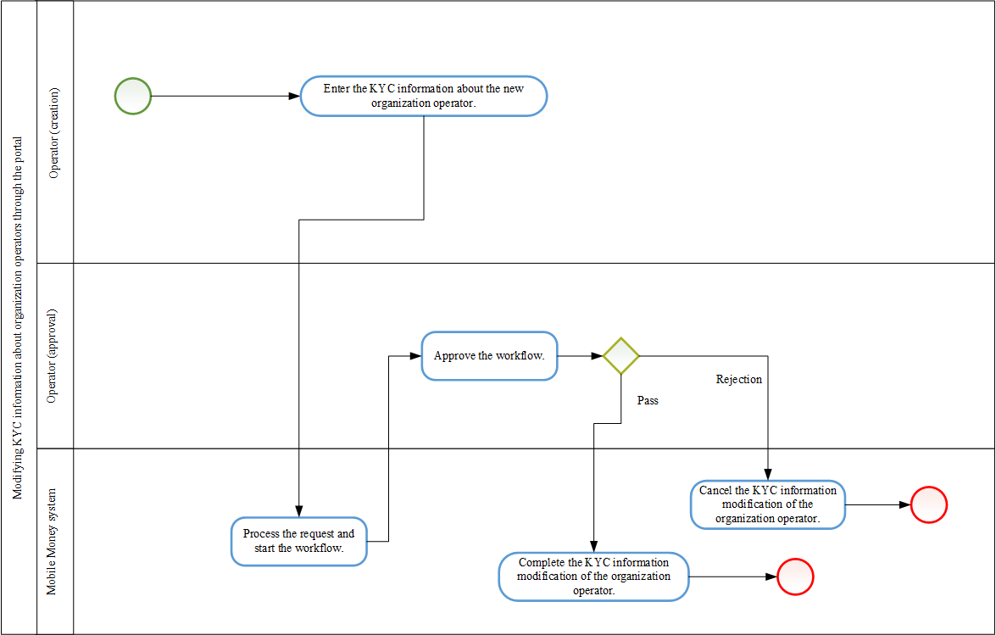

In the preceding process, the system determines whether approval is required (generally, approval is required) based on the workflow configuration. If approval is not required, after the organization operator submits the request, the system directly modifies KYC information about the organization operator.

The service process of modifying KYC information about organization operators through APIs complies with the common service process of Generic APIs. When APIs are used to modify KYC information about organization operators, the system determines whether approval is required based on the workflow configuration. If approval is required, the approval needs to be completed on the portal.

The service process of modifying KYC information about organization operators in batches using bulk tasks is the same as all other batch processing processes performed using bulk tasks. An operator uploads the file on the portal to create a bulk task to modify KYC information about organization operators in batches. During batch organization operator KYC information modification, organization operators are not approved one by one. For the entire bulk task, the system determines whether to perform approval based on the workflow configuration. Generally, approval is required.

### User Experience

The following figure shows the page for modifying KYC information about organization operators on the portal.

Figure 6-2 shows the button for modifying organization KYC information on the organization identity page.

Choose **Identity** > **Organization** and put the **organization short code** and input some information about the operator like **Full name**, **username** and so on, then click **search** as shown in the figure 7-1.

Organization Operator KYC management process.

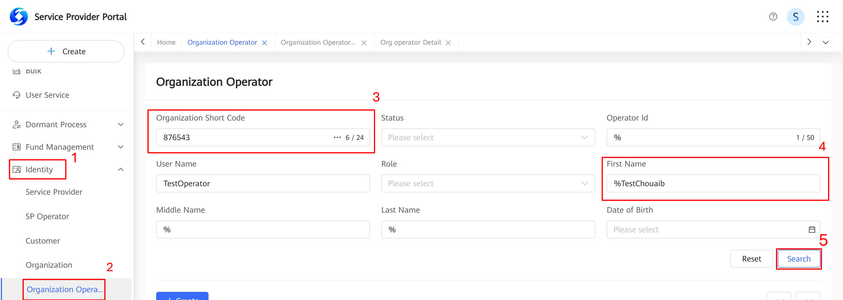

Then click **Detail.**

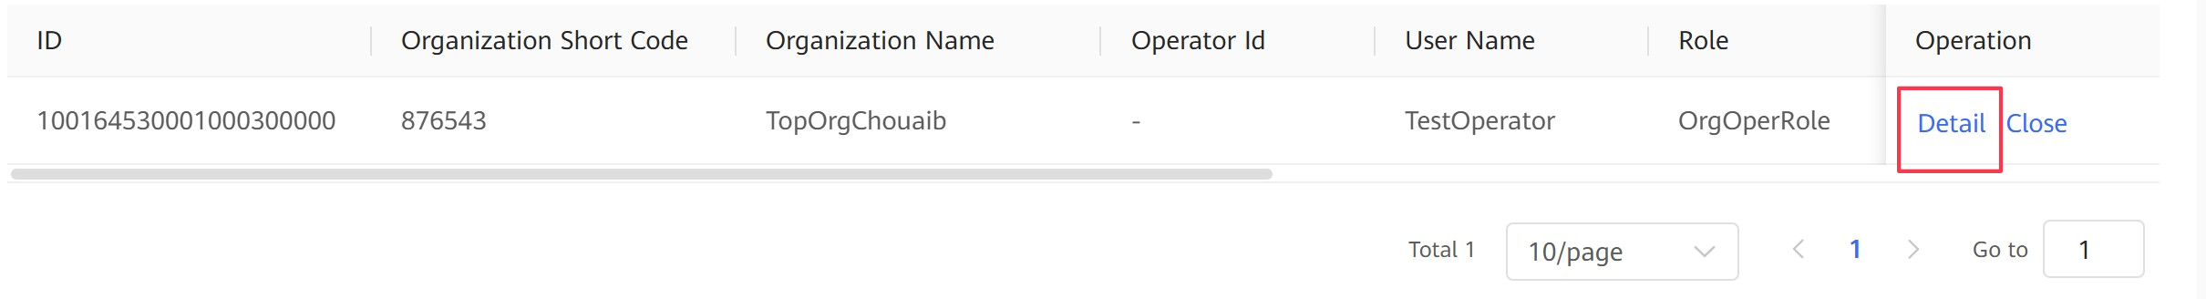

Button for modifying organization operator KYC information on the organization identity page.

An organization operator clicks the edit button. The edition area of fields is displayed, as shown in the following figure.

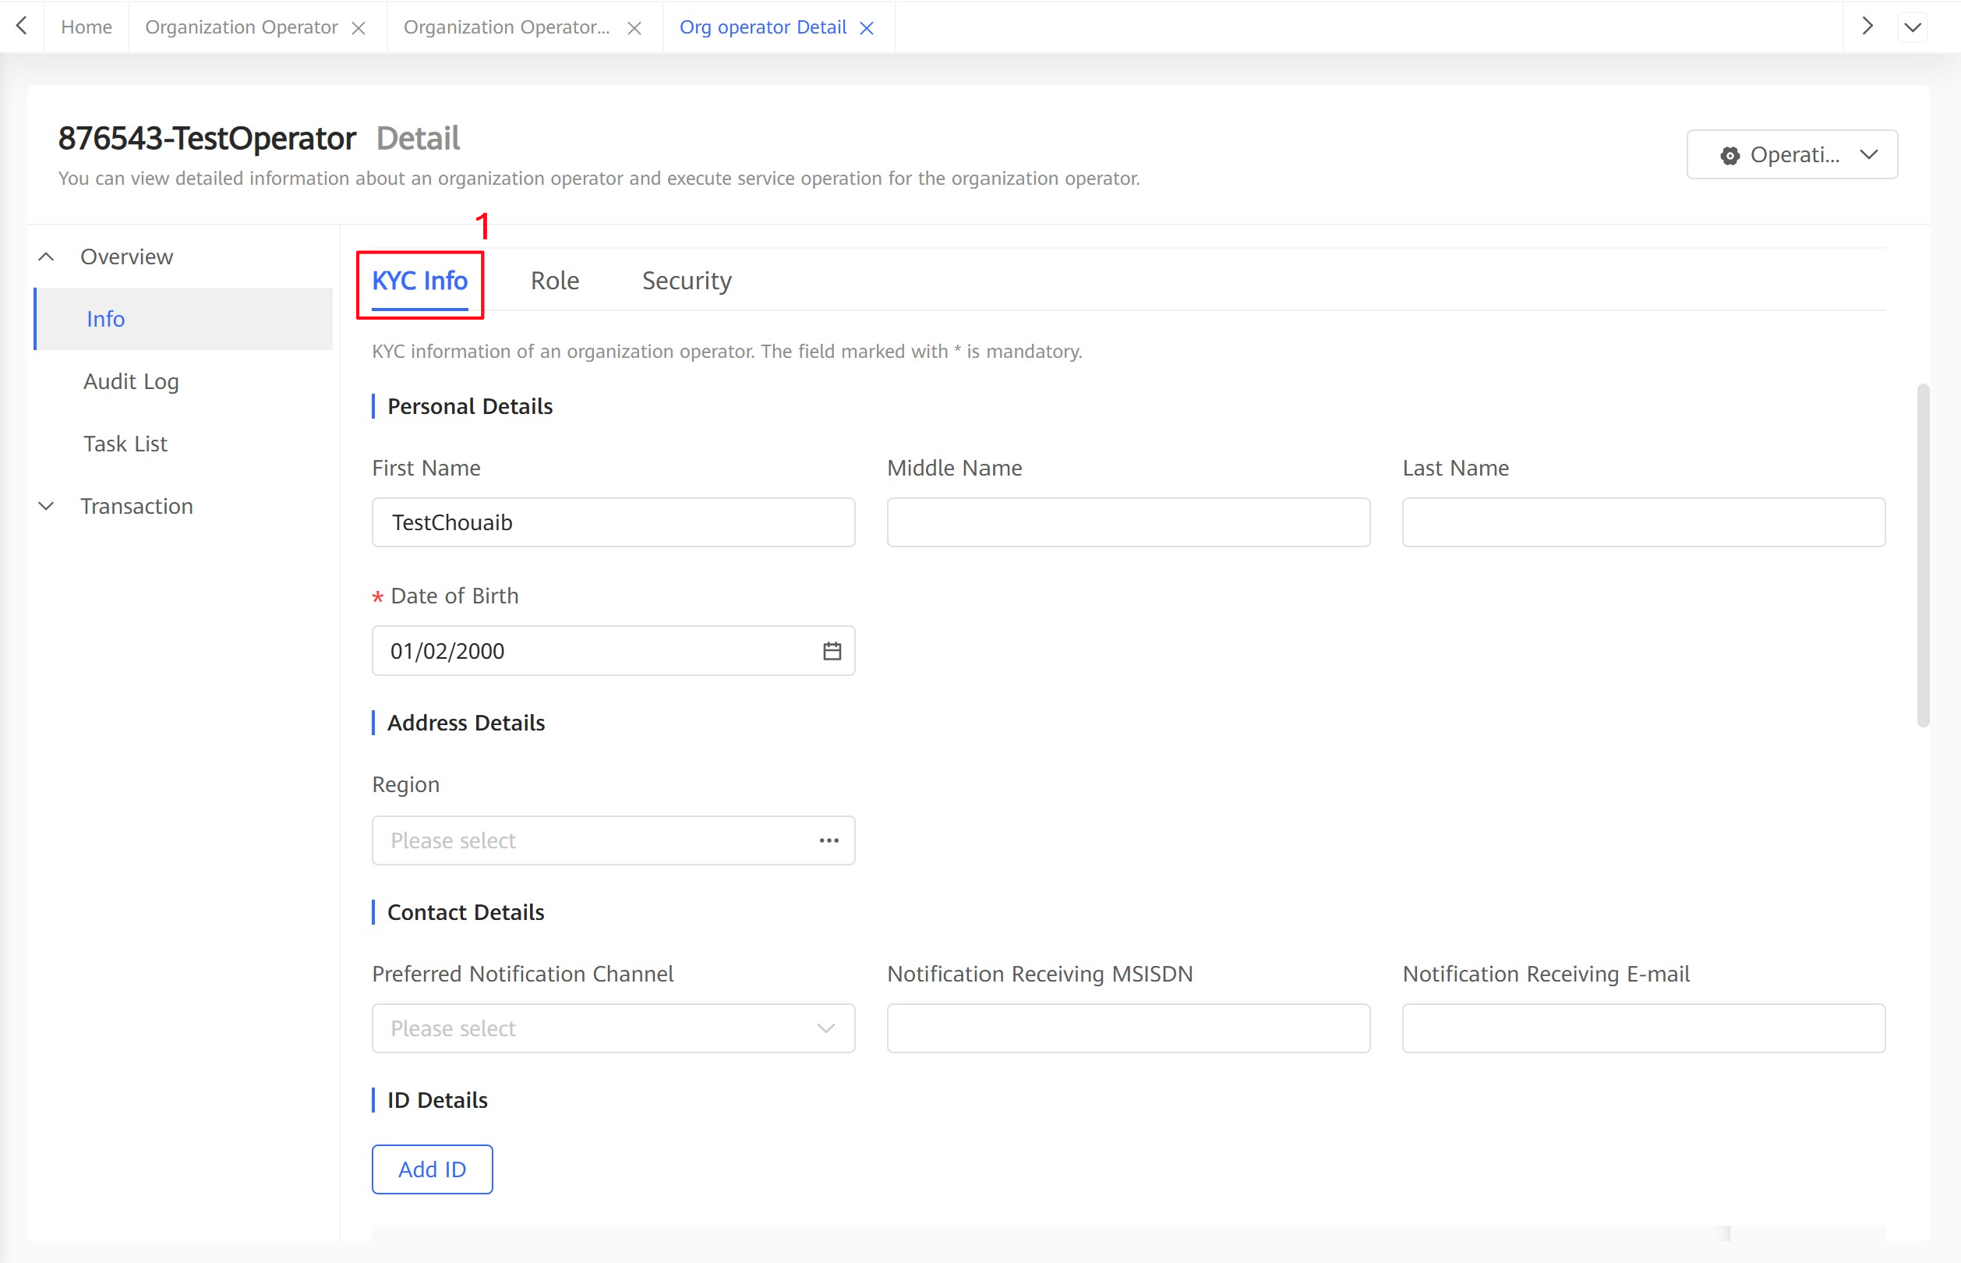

.

After setting the KYC fields, the organization operator submits a request to the system background. Then the system checks the KYC field values and returns the verification errors to the customer.

After the organization operator confirms the errors and modifies the fields, the system creates a workflow and determines whether approval is required based on workflow configurations. The service process of workflow task approval is the same as that of other workflow tasks.

The service process of changing the KYC information about organization operators through APIs is determined by external systems. The system determines whether approval is required based on the workflow configuration. If approval is required, the approval needs to be completed on the portal. The service process is the same as that of approval of KYC field modification on the portal.

The service process of modifying KYC information about organization operators in batches using bulk tasks is the same as all other batch processing processes performed using bulk tasks.

### Configuration Points

Permission

The role of operator needs execution permissions named **Manage Identity** > **Organization Operator** > **Change Operator KYC** to change organization KYC.

## Specifications

Technical Specifications

**Organization Operator KYC Field Setting**

The following table lists organization operator KYC fields. A site can determine whether to use the fields based on the site requirements.

| KYC Group | KYC Field | Remarks |
| --- | --- | --- |
| Personal Details | First Name | - |
| Middle Name | - |
| Last Name | - |
| Date of Birth | - |
| Address Details | Region | A multi-level region list can be configured in the system. When setting this KYC field, an SP operator can select a value from the tree view. |
| Risk Details | Risk Rating | Customer risk level. Generally, the AML system or another external system analyzes the field to obtain the value and updates the field to the Mobile Money system for the operators. |
| Modification Time of Risk Rating | This field cannot be modified. The system automatically records the last modification time of the **Risk Rating** field. |
| Contact Details | Preferred Notification Channel | This field indicates the channel used to send organization notifications. The options are **SMS** and **E-mail**. |
| Notification Receiving MSISDN | This field must be set when **Preferred Notification Channel** is set to **SMS**. |
| Notification Receiving E-mail | This field must be set when **Preferred Notification Channel** is set to **E-mail**. |
| ID Details | ID Type | Certificate type. |
| ID Number | Certificate number. |
| ID Effective Date | Start date of the certificate validity period. |
| ID Expiry Date | End date of the certificate validity period. |
| Document Received | - |
| Certificate Details | Certificate Type | - |
| Certificate Number | - |
| Certificate Certified Date | - |
| Certificate Expiry Date | - |
| Accounting Mode | - |

The KYC fields in the ID Details and Certificate Details groups support multiple values. When certificates and IDs of organization operators are set, the system provides a list for multiple values. Other KYC fields have only one value.

A site can use the preset KYC fields and define KYC field groups and fields. However, a site can define only single-value KYC field groups and fields and cannot add KYC fields to the multi-value KYC group.

Standards Compliance

None

## Enhancements

None

## Reference

None

1. Acronyms and Abbreviations

| Acronym or Abbreviation | Full Name | Description |
| --- | --- | --- |
|  |  |  |